MUST Social Network



By
Muhammad Ubaid Raza 1JX26000AL005UV
Karamat Hussain 1JK260009U1005PJ M Junaid Shabbir -

Project Supervisor
_______________
Engr. Samiullah Khan
Lecturer

Department of Software Engineering
Mirpur University of Science and Technology

October, 2017

Certification
_________________________________________________________________

It is certify that the following students have completed their project on
“MUST Social Network”
Submitted By:

Muhammad Ubaid Raza 13-SE-59
Karamat Hussain 13-SE-64
M Junaid Shabbir 13-SE-54

Session: 2013-17

This report is submitted in partial fulfillment of the requirements of the award of degree of Bachelors of Software Engineering. Mirpur University of Science and Technology (MUST).

_____________________ __________________
External Examiner Project Supervisor
(Samiullah Khan)

________________________________
Chairman
Department of Software Engineering
MUST Mirpur (A.K)

Abstract
______________________________________________________________

Our aim is to develop a "MUST Social Network" which is easily accessible to the teacher, students, staff and administration as well. This system regulates the activities between students and teachers and provide a single platform in order to communicate with each other. Students can communicate with teachers that are available in this network and ask questions about their problems.

Undertaking
_________________________________________________________________
We certify that the work titled “MUST Social Network” is our own work. The work has not, in whole or in part, been presented elsewhere for assessment. Where material has been used from other sources it has been properly acknowledged/ referred.

_______________
Muhammad Ubaid Raza
1JX26000AL005UV

_______________
Karamat Hussain
1JK260009U1005PJ

_______________
M Junaid Shabbir
-

Acknowledgement

All the praise and glory to Allah, Who blessed us with the courage and knowledge to achieve our goal. We can never thank Him enough for His countless blessings upon us. Praise to Prophet Mohammad (S.A.W), who is and will always be a source of guidance and knowledge for humanity as a whole.

For us, a mile stone of this nature would never have been possible to achieve without the support of galaxy of some truly loving and kind people in our life. No words can fully describe our feelings of respect and gratitude for our affectionate parents, supporting sibling and friends, whose love, encouragement and prayers invariably buoyed us up. Their concern, love and support can never be paid back.

We owe a lot of sincere gratitude to our respected supervisor Samiullah Khan, whose true guidance, positive criticism and sincere encouragement made us to get to our destination. He became a source of inspiration for us and kept us moving in the right direction towards our goal.

Table Of Content
_________________________________________________________________

Certification i
Abstract ii
Undertaking iii
Acknowledgement iv
Table Of Content v
Abbrevations 1
Introduction: 2
1.1Problems in Existing System: 2
1.2 Solution of these Problems: 2
1.2.1 Proposed System & Its Modules: 2
1.3 System Conception 3
1.3.1 Who is the application for? 3
1.3.2 What problem will it solve? 3
1.3.3 Where it will be used? 3
1.3.4 When it is needed? 3
1.3.5 Why it is needed? 3
1.4 Advantages for Students 4
1.5 Advantages for Faculty 4
1.6 Proposed Project’s Need 4
1.7 Software Process Model 5
1.8 Project Boundaries 5
1.9 Scope of Document 5
1.10 Software Used 5
1.11 Deployment 6
1.12 Hardware Specification 6
Feasibility Study: 7
2.1 User Needs: 7
2.2 How we fulfill Needs: 7
2.3 Project Feasibility: 7
2.3.1 Technical Feasibility 7
2.3.2 Technical Feasibility-Hardware 7
2.3.3 Technical Feasibility-Software 8
2.3.4 Schedule Feasibility 8
2.3.5 Economic Feasibility 8
2.4 Social and Ethical Considerations: 8
2.5 Project Planning: 8
2.5.1 Work Breakdown Structure of Project: 8
2.6 Gant Chart 9
Design: 10
3.1 Design Approach: 10
3.2 Database Design: 10
3.3 Object Modeling Technique (OMT): 10
3.3.1 Class Model 10
3.3.2 Interaction Model 11
3.4 Conceptual Design: 11
3.4.1 Association 11
3.4.2 Classes and their attributes 13
3.5 Class Diagram 13
3.6 Logical Design 15
3.6.1 Relation 15
3.6.2 Associating Tables 15
3.7 Physical Design 15
3.8 Data types and Variable Lengths 16
3.9 Database Diagram 19
3.10 Use Case Diagrams: 20
3.10.1 Use Cases Description 21
3.11 Sequence Diagrams 25
3.12 Activity Diagram 32
Implementation: 40
4.1:Login Panel : 40
4.2: Register User 41
4.3 Add User 41
4.4 Block/Unblock User 42
4.5 Event Alert 42
4.6 Event Gallary 43
4.7 : Messaging 43
4.8 : User Profile 44
4.9 : Home Page 44
Testing: 45
5.1 Psychology of Testing 45
5.2 Testing Objective 45
5.3 The Box Approach 46
5.3.1 White Box testing 46
5.3.2 Black Box testing 46
5.4 Levels of Testing 46
5.5 Unit Testing 47
5.6 Integration Testing 47
5.7 System Testing 48
5.8 Alpha Testing 48
5.9 Beta Testing 48
5.10 Acceptance Testing 48
5.11 Interface Testing 49
5.12 MUST Social Network Testing 49
5.13 Test Cases 49
5.13.1 Test Case 1: Sign-up 50
5.13.2 Test Case 2: Login 50
5.13.3 Test Case 3: Create Conversation 51
5.13.4 Test Case 4: View Conversation 51
5.13.5 Test Case 5: Delete Conversation 52
5.13.6 Test Case 6: Check Conversation 52
5.13.7 Test Case 7: Add Member 53
5.13.8 Test Case 8: Ban Member 53
5.13.9 Test Case 9: Show Member 54
5.13.10 Test Case 10: Status Check 54
5.13.10 Test Case 10: Status Check 55
5.13.11 Test Case 11: view Profile 55
5.13.12 Test Case 12: Update Profile 56
5.13.13 Test Case 13: Delete Member 56
5.13.14 Test Case 14: View Status 57
5.13.15 Test Case 15: Delete Status 57
5.13.16 Test Case 16: Update Status 58
5.13.17 Test Case 17: Insert Status 58
5.13.18 Test Case 18: Insert Profile Picture 59
5.13.19 Test Case 19: Show Profile Picture 59
5.13.20 Test Case 20: Change Profile Picture 60
5.13.21 Test Case 21: Delete Profile Picture 60
5.13.22 Test Case 22: Insert Photo In Event Gallery 61
5.13.23 Test Case 23: Delete Photo From Album 61
5.13.24 Test Case 24: Show Album Photo 62
5.13.25 Test Case 25: Slider 62
5.13.26 Test Case 26: Add Event 63
5.13.27 Test Case 27: Edit Event 63
5.13.28 Test Case 28: Delete Event 64
5.13.29 Test Case 29: Show Event 64
5.13.30 Test Case 30: Like 65
5.13.31 Test Case 31: Unlike 65
5.13.32 Test Case 32: Like Show 66
5.13.33 Test Case 33: Like Count 66
5.13.34 Test Case 34: Insert Message 67
5.13.35 Test Case 35: Delete Message 67
5.13.36 Test Case 36: Show Message 68
5.13.37 Test Case 37: Check Message Status 68
5.13.38 Test Case 38: Add Comment 69
5.13.39 Test Case 39: Edit Comment 69
5.13.40 Test Case 40: Delete Comment 70
5.13.41 Test Case 41: Show Comment 70
Conclusion And Future Work: 71
6.1 Conclusion 71
6.2 Future Improvements 72
6.3 Limitations 72
Conclusion 73
Referencing 74

Abbrevations
_________________________________________________________________

MUST: Mirpur University of Sciences and Technology
MSN: MUST Social Network
PHP: PHP Hypertext Preprocessor
HTML: Hyper Text Markup Language
JS: Java Script
CSS: Cascading Style Sheet
DB: Database
SMS: Short Message Service
OMT: Object Modeling Technique

Introduction:

We want to make a project that will help the university staff to alert the students about any event that is going to happen. We are going to introduce a social network website which will gather the university staff and students on a platform. On that platform students are informed about any event that is going to happen in the university. This will notify the students about events on MUST social network as well as they will receive text SMS on mobile phone without having internet connection. In this website we will also provide the pictures of events in events gallery.

1.1Problems in Existing System:
Currently there is no social network of MUST. There is no organized photo collection. Students face different problems. For example if a student wants to communicate with a teacher then there is no effective way of communication. Notice board concept is too old. It is often ignored by students. If any announcement is made then many students did not aware of it. There is no discussion portal for the MUST students.

1.2 Solution of these Problems:
Solution of these problems can be overcome in the following way:

1.2.1 Proposed System & Its Modules:
The aim of the MUST Social Network is to provide communication among teacher, student and staff. The system after careful analysis has been identified to be presented with the following modules:

- Event alert: Admin and staff can generate event alert. The users can receive an event alert on their mobile phone through an SMS.
- Post Status: Everyone can post status. Users are also able to comment and like on the status.
- Event Gallery: Events photos will be uploaded in the network website. Everyone can view photo and play slides.
- Online chat: Every member can chat with other members using chat feature. Last seen and message seen features will be provided.

1.3 System Conception
Most of the system starts as vague ideas that need more substance. A good system concept must answer the following questions as our system has:

1.3.1 Who is the application for?
This network is for MUST. It is for education purpose. This is the social network for the MUST which will provide basic feature to its members. There are some unique features for example event alert and event gallery. Which are not present in other social networks. MUST will be the first university which will have its social network. This network can be used by students, teachers and staff of the university.

1.3.2 What problem will it solve?
Our system overcome the different kinds of problems such as
- Old notice board concept
- Albums for the events
- Deficiency of communication
- Discussion portal

1.3.3 Where it will be used?
Our system will be used in Mirpur University of Sciences & Technology.

1.3.4 When it is needed?
It is needed to minimize the investment and maximize the revenue in economic sense. Our system removes the old notice board concept. It will provide effective communication among MUST members.

1.3.5 Why it is needed?
Our system is according to modern concept. Students will be notified by website as well as by an SMS. Chat is provided among members so student can ask question from teachers. Teacher can make announcement about quiz and assignment.

1.4 Advantages for Students

Advantages for the students are explained below

- On time alert: Student will be alerted on time. Students can receive alert about an event in few seconds.
- Gallery: If anyone misses an event then he can view photos of event.
- Chat: Students can chat with teachers and can discuss their problems.
- Discussion: Student can discuss any problem using post feature. On which every member can comment.

1.5 Advantages for Faculty
Alert: Faculty can alert student about an event in one click during holiday
Easy to contact: Faculty can contact any member of university easily.
Project Need: Communication between university teachers and students.

1.6 Proposed Project’s Need
- To remove students problems which they are facing due to absence of an effective network.
- To provide alerts to students in time.

1.7 Software Process Model
Software process model is an abstract representation of a software process, which is a set of activities that leads to the production of a software product. Some of the generic process models are waterfall model, evolutionary development and component based software engineering. For this project we will follow iterative waterfall process model, because of clear and unchanging business requirements.

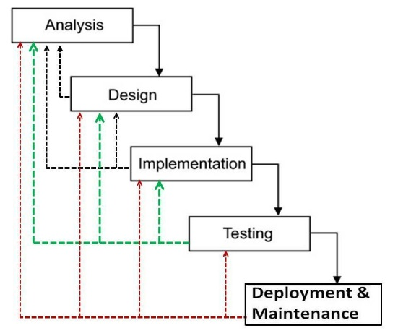

Fig 1.1: Iterative Waterfall Model

1.8 Project Boundaries
The overall project scope is within our university, but it can be used in any college, school and university.

1.9 Scope of Document
This document will theoretically describe how the application is designed, implemented, and the scope of the application. This documentation can be used by teacher and students for study purpose.

1.10 Software Used
We will use following software tools to implement this project:
- Database Server: My-SQL
- Client: Microsoft Internet Explorer or any web browser
- Development Tools: Dreamweaver
- Programming Language: PHP, AJAX, JQUERY, JAVASRCIPT

1.11 Deployment
- Operating System Server: Window 8.1

1.12 Hardware Specification
The following hardware tools will be required to implement this project:
- Processor: Intel Core i3
- RAM: 4GB
- Hard Disk: 260 GB

Feasibility Study

This document contains the feasibility of the proposed project and describes in details the schedule plan we have opted to develop current project.

2.1 User Needs:
User wants the fully automated system with all the requirements mentioned in the scope of this project. He wants the application which can give optimal results, with improved performance and less development cost.

2.2 How we fulfill Needs:
User needs will be fulfilled by using up to marks techniques. Moreover, the application will be developed within the timeframe and cost, estimated before the project development. We will develop centralized application which is easy to maintain and which can perform efficiently as compared to the manual computation of user’s project.

2.3 Project Feasibility:
This section define that whether the project is worth solving or not.

2.3.1 Technical Feasibility
This project does not need such hardware for development, design and continued operation that is to be bought, but only the hardware that both the developers and the organization use in daily life like laptop. And so the project is technically feasible with respect to hardware.

2.3.2 Technical Feasibility-Hardware
No extra hardware required, Pentium 4 or higher required which is easily available in market.

2.3.3 Technical Feasibility-Software
- Window8
- Dream Weaver
- My-Sql

2.3.4 Schedule Feasibility
The proposed project is medium level but its modules are time consuming, our estimate time after paper works is about 4 months, this project will complete in four months (120 Days) with its full specifications. With hard work and full dedication, we will be able to deliver the system on time.

2.3.5 Economic Feasibility
A system can be developed technically and that will be used if installed must still be a good investment for the organization. In the economic feasibility, the development cost in creating the system is evaluated against the ultimate benefit derived from the new systems. Financial benefits must equal or exceed the costs.
The system is economically feasible. It does not require any addition hardware or software. Since the interface for this system is developed using the existing resources and technologies available. There is nominal expenditure and economic feasibility for certain.

2.4 Social and Ethical Considerations:
The under described project does not contradict to any of the social or ethnic value. Our project does not affect the social and moral values of our society. It does not harm the feelings of other in fact, it is social network that provide a single platform to communicate with each other in order to share problems with teacher. Our network is limited to Mirpur University of Sciences and Technology so, this network does not violate ethics and does not perform any unethical activity that can harm others.

2.5 Project Planning:
Project planning is listed below

2.5.1 Work Breakdown Structure of Project:
- Project Definition
- Project Approval
- System Conception
- System Analysis
- Domain Model
- Application Model
- System Design
- Class Design
- Implementation
- Deployment
- Support Personal Training

2.6 Gant Chart

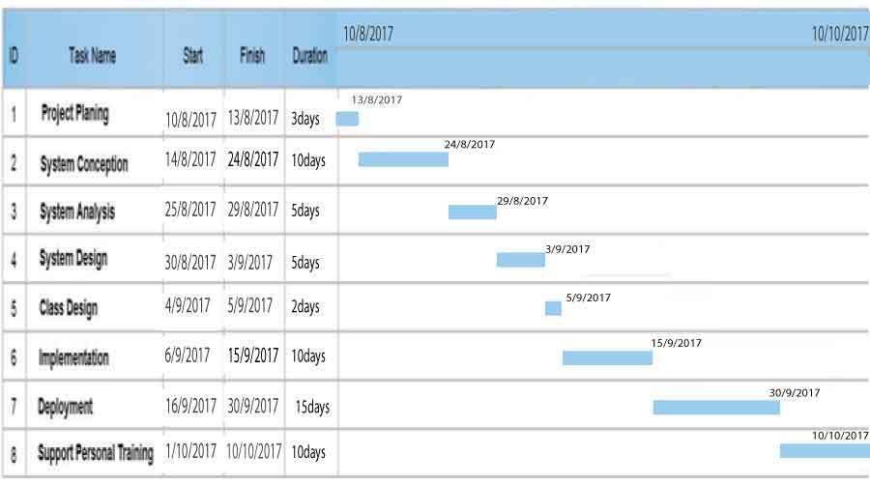
Fig 2.1: Gant Chart

Design:

Design is the first step in the development phase for any engineered product or system. The designer’s goal is to produce a model or representation of a class that will later be built. Designing is the foundation of whole development process. If we obtain a perfect design of a system then efficient and effective software can be developed on the other hand if there are some concepts we have not clear them the result will be opposite to previous case. Software with the bugs and failure will be achieved. So designing phase is really important in this phase we translate requirements into the software structure. This is one of the important step in development every functionality of program depends upon it.

3.1 Design Approach:
Design approach for this software is conventional, that is, database model used is relational and on the other side Object modeling technique (OMT) is used.

3.2 Database Design:
This system would have a database as its data store, so the design of the database is very important. We chose relational database model for our database. Database design includes conceptual, logical and physical design phases, which are discussed in this section.

3.3 Object Modeling Technique (OMT):
OMT is object oriented design approach, here we used two fundamental modeling techniques which are class and interaction modeling.

3.3.1 Class Model
The class model shows static class objects in a system and the relationships between them. Two particularly important relationships are generalization (inheritance) and aggregation each class object on the diagram often shows the class name, its attributes and operations. Here we capture the real world concepts that are important to our application.

3.3.2 Interaction Model
This model describes the interaction between the objects. Its diagrams are
- Use Case Diagram
- Sequence Diagram
- Activity Diagram
3.4 Conceptual Design:
Conceptual design is about understanding the organization, the real world modeling; it captures the essence of the real world scenario. In this phase all the important classes of the system are extracted with their essential attributes and the relationship between them are established. This results in class diagram

3.4.1 Association
The relationship between the extracted tables is tabulated in table 3.1.

3.4.2 Classes and their attributes

The classes that are used in our social network and their attributes are identified. Their description is also discussed. Every class with its attributes is given in the table 3.2:

Class Name | Multiplicity | Relationship | Multiplicity |  | Class Name
Admin | 1 | Can send/receive | * |  | message
Student | 1 | Can send/receive | * |  | message
Staff | 1 | Can send/receive | * |  | message
Teacher | 1 | Can send/receive | * |  | message
Admin | 1 | Can post | * |  | Status
Teacher | 1 | Can post | * |  | Status
Staff | 1 | Can post | * |  | Status
Student | 1 | Can post | * |  | Status
Admin | 1 | Can like | * |  | Like
Teacher | 1 | Can like | * |  | Like
Staff | 1 | Can like | * |  | Like
Student | 1 | Can like | * |  | Like
Admin | 1 | Can comment | * |  | Comment
Teacher | 1 | Can comment | * |  | Comment
Student | 1 | Can comment | * |  | Comment
Staff | 1 | Can comment | * |  | Comment
Admin | 1 | Can generate | * |  | eventAlert
Staff | 1 | Can  Receive | * |  | eventAlert
Admin | 1 | Can upload | * |  | eventGallery
Staff | 1 | View | * |  | eventGallery
Admin | 1 | Can send | * |  | Message
Staff | 1 | Can send | * |  | Message
Student | 1 | Can send | * |  | Message
Teacher | 1 | Can send | * |  | Message
Admin | 1 | Can block | * |  | Members
Table 3.1: Association

Class Name | Description | Attributes
Profile pic | User profile picture | currentStatus, name, picHolderId,PicDate
Member | User of the network | Id, firstName, lastName, email, password, lastseen, cnic, city, dob, gender, position
Status | Status which a user wants to post | Id, status, posterName, date
Conversation | To check the conversation exist in two members | Id, firstPersonId, secondPersonId, date, del1 ,del2
Event gallery | Consist of events photo | Id, eventName, photoName, date
Event Alert | Provide event alert through a post and sms | Id, event, date alertReciever
Likes | Provide option to like a status | Id, likerId, likerName, likes
Comment | Provide option to comment on a status | commenterId, commenterName, date, comment
Table 3.2: Classes and Attributes

3.5 Class Diagram
After the identification of classes their attributes and the relationships among them our class diagram is given below.

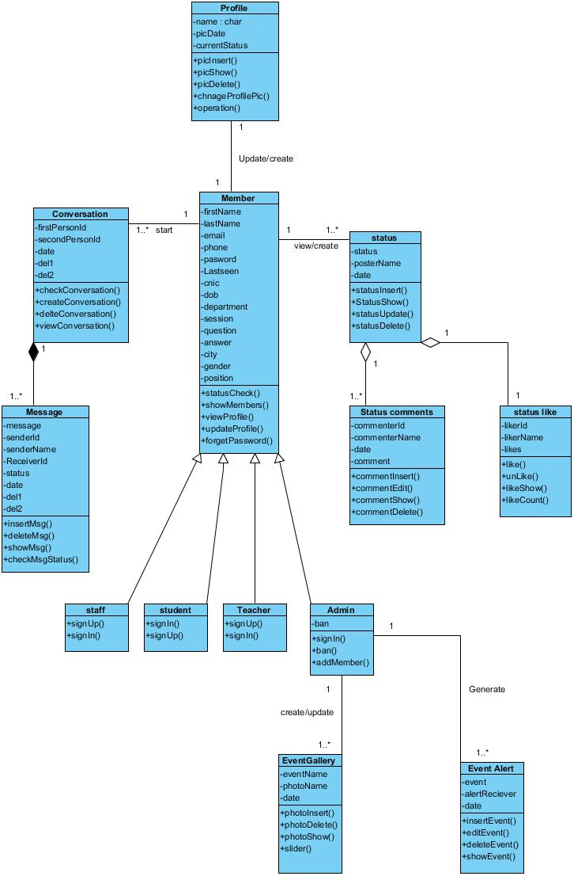Fig 3.1: Class diagram

3.6 Logical Design
Logical database design is the process of transforming the conceptual data model into a logical data model. The logical model we will use is object data model. It represents data in the form of tables/relations.

3.6.1 Relation
A relation is a named, two-dimensional table of data. Each relation (or table) consists of a set of named columns and an arbitrary number of unnamed rows. An attribute is a named column of a relation. Each row of a relation corresponds to a record that contains data (attribute) values for a single class.
Primary key is an attribute or a combination of attributes that uniquely identifies each row in a Relation.
Foreign key is an attribute (possibly composite) in a relation that serves as the primary key of another relation.

3.6.2 Associating Tables
During logical design, we transform the class diagram that was developed during conceptual design into relational database schemas. The inputs to this process are the class diagram and the outputs are the relational schemas. Regular tables are classes that have an independent existence and generally represent real-world objects, such as persons and products. Each regular table type in a class diagram is transformed into a relation. The name given to the relation is generally the same as the table type. Each simple attribute of the table type becomes an attribute of the relation. The identifier of the table type becomes the primary key of the corresponding relation.

3.7 Physical Design
Physical database design produces the technical specifications that programmers, database Administrator, and others involved in information systems construction will use during the implementation phase. Physical database design requires critical decisions that will affect the performance of the application system like choosing the storage format (called data type) for each attribute from the logical data model. The format is chosen to minimize storage space.

3.8 Data types and Variable Lengths
Attributes along with their specific data type and length that are used in our social network are identified and given are as follows:

Table 3.3: Profile Pic

Attribute | Data type | Length
Id | Int | 30
Name | Varchar | 30
PicHolderId | Int | 30
PicDate | Varchar | 30
currentStatus | Varchar | 30

Table 3.4: Members

Attribute | Data type | Length
Id | Int | 30
FirstName | Varchar | 100
LastName | Varchar | 100
Email | Varchar | 100
Password | Varchar | 30
Lastseen | Varchar | 50
Cnic | Int | 13
Dob | Varchar | 30
Gender | Varchar | 10
Position | Varchar | 30
Ban | Varchar | 2
Department | Varchar | 30
City | Varchar | 30
Phone | Varchar | 13
Security Question | Varchar | 30
Answer | Varchar | 30

Table 3.5: Status
Attribute | Datatype | Length
Id | Int | 30
Status | Varchar | 255
statusPosterId | Int | 30
posterName | Varchar | 30
Date | Varchar | 30

Table 3.6: Conversation

Attribute | Datatype | Length
Id | Int | 30
firstPersonId | Int | 30
SecondPersonId | Int | 30
Date | Varchar | 30
Del1 | Int | 1
Del2 | Int | 1

Table 3.7: Event Gallery

Attribute | Datatype | Length
Id | Int | 30
EventName | Varchar | 255
PhotoName | Varchar | 200
PhotoUploaderId | Int | 30
Date | Varchar | 30

Table 3.8: Event Alert

Attribute | Datatype | Length
Id | Int | 30
Event | Varchar | 255
alertReciever | Varchar | 30
alertGeneratorId | Int | 30
Date | Varchar | 30

Table 3.9: Status Like

Attribute | Datatype | Length
Id | Int | 30
LikerId | Int | 30
LikerName | Varchar | 30
StatusId | Int | 30

Table 3.10: Status Comment

Attribute | Datatype | length
Id | Int | 30
commenterId | Int | 30
commenterName | Varchar | 30
StatusId | Int | 30
Like | Int | 1

Table 3.11: Message
Attribute | Datatype | Length
Id | Int | 30
Message | Varchar | 255
SenderId | Int | 30
senderName | Varchar | 30
recieverId | Int | 30
Status | Int | 2
Date | Varchar | 30
Del1 | Int | 1
Del2 | Int | 2

3.9 Database Diagram

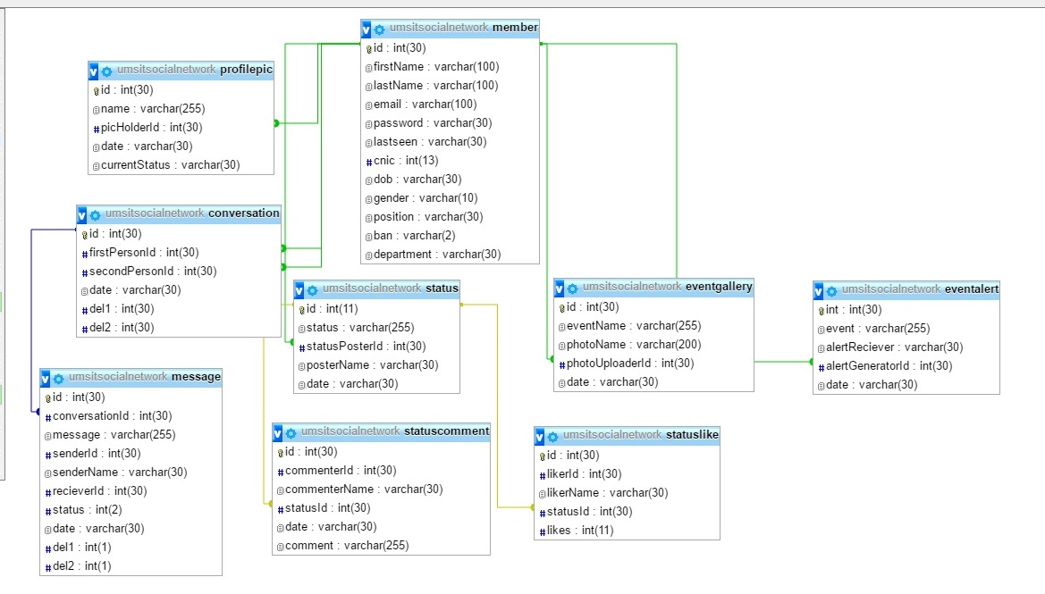 Fig 3.2: Database

3.10 Use Case Diagrams:
Use case diagram is used to capture the dynamic nature of a system. It consists of use cases, actors and their relationships. It is used at a high level design to capture the requirements of a system.

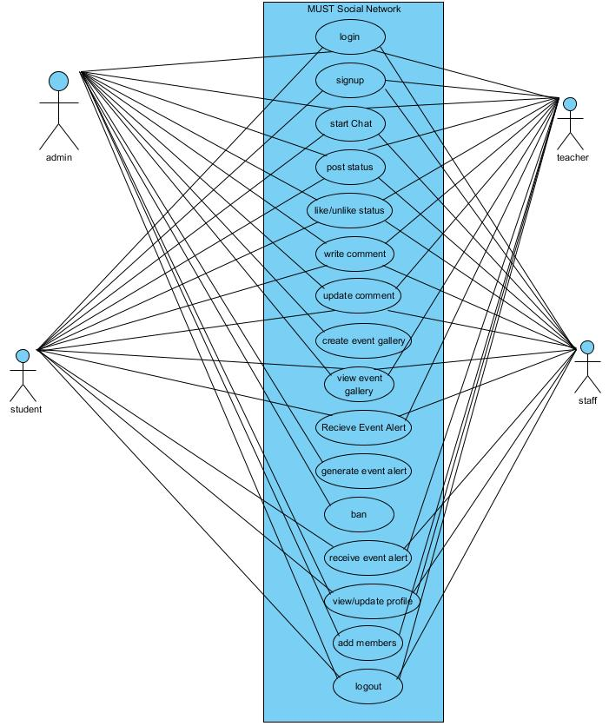
Fig 3.3: Use case

3.10.1 Use Cases Description
Description of Use Case logout

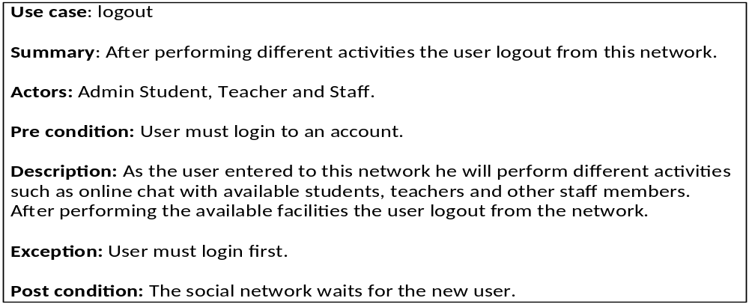
Description of Use Case Chat

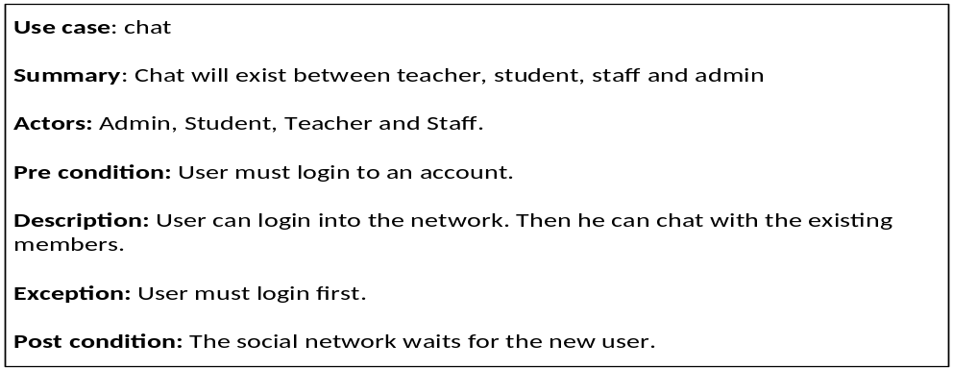

Description of Use Case Login
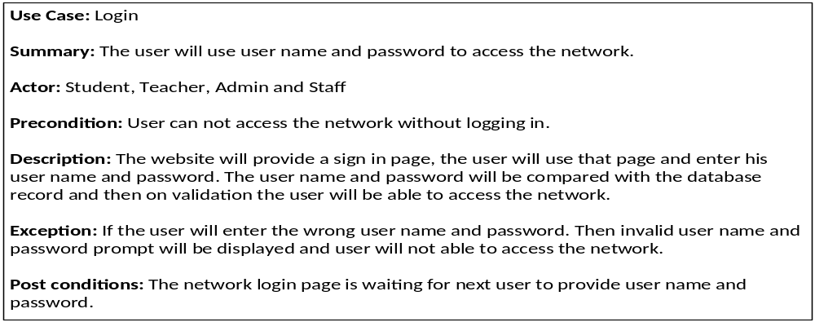
Description of Use Case Status

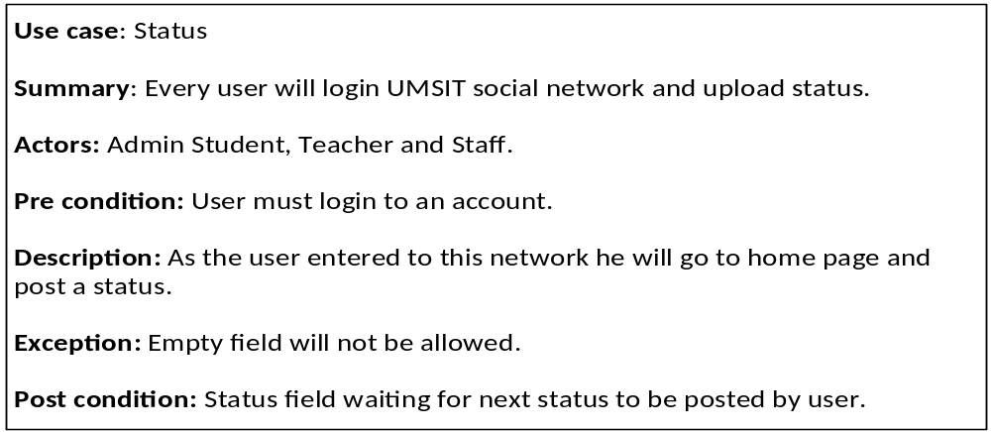
Description of Use Case Profile

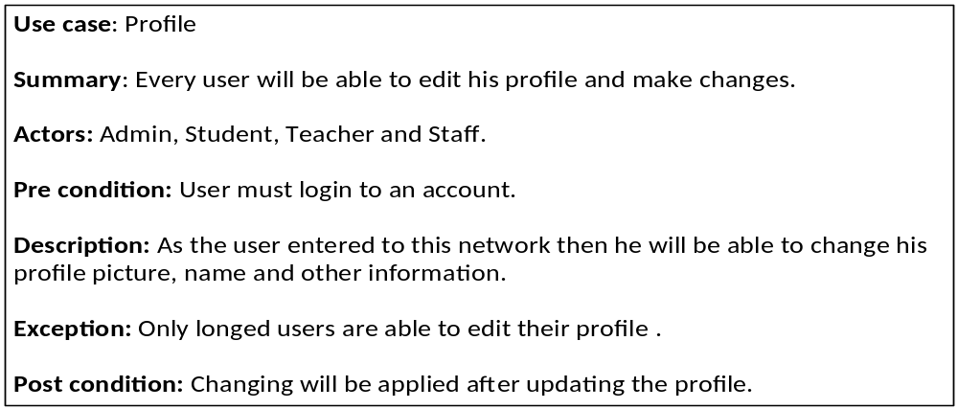

Description of Use Case Event Gallery

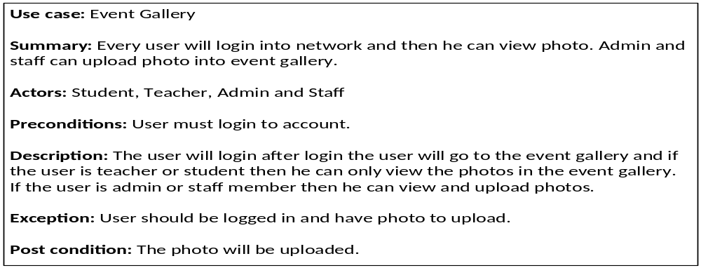
Description of Use Case Sign Up
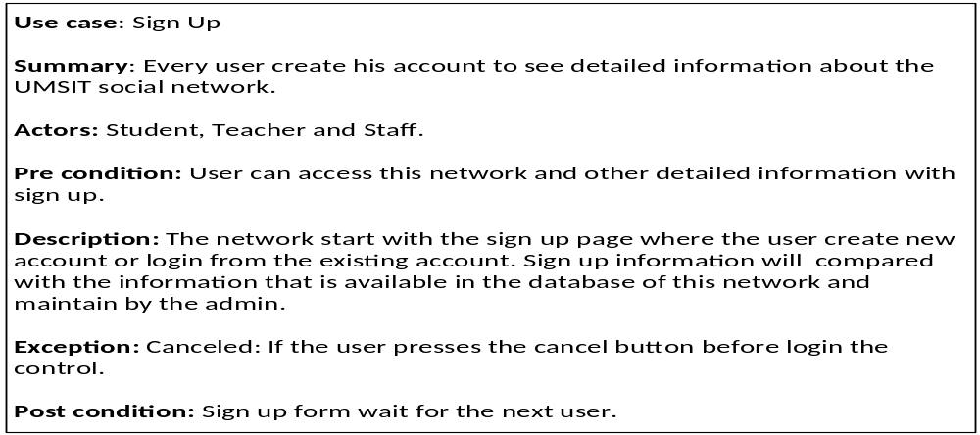
Description Use Case of Comment

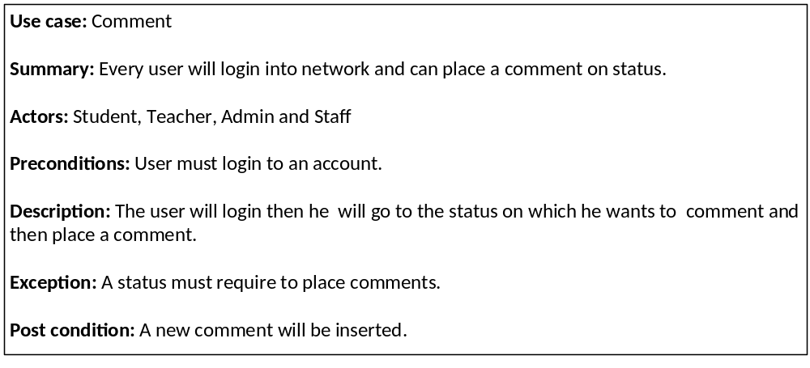
Description of Use Case Like/ Unlike

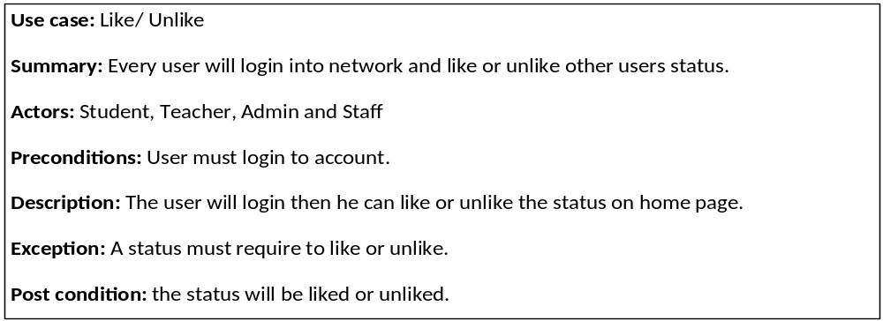 Description of Use Case member list

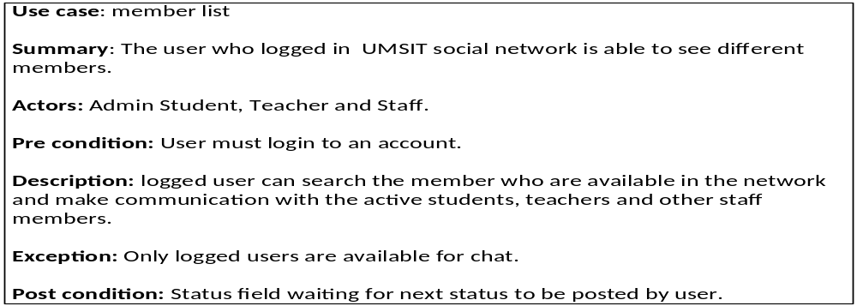
Description of Use Case event alert

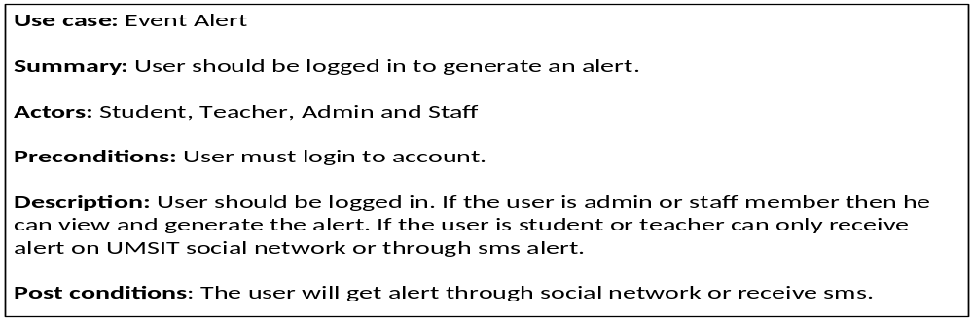

3.11 Sequence Diagrams
Sequence diagrams are used to capture time ordering of message flow in a system. Message from user actions flow towards system and system sends response message back to user.

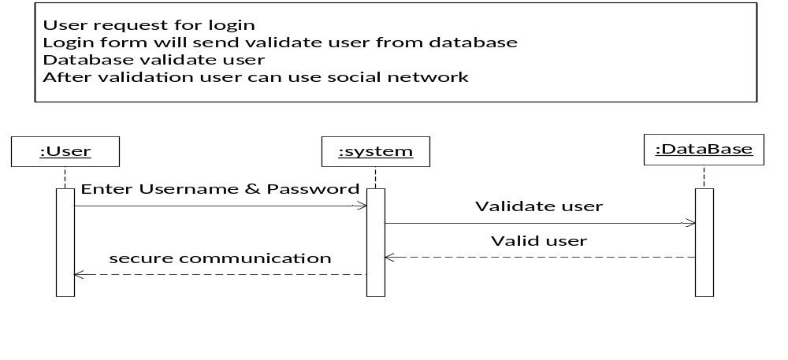Fig 3.4: Login Scenario Sequence Diagram

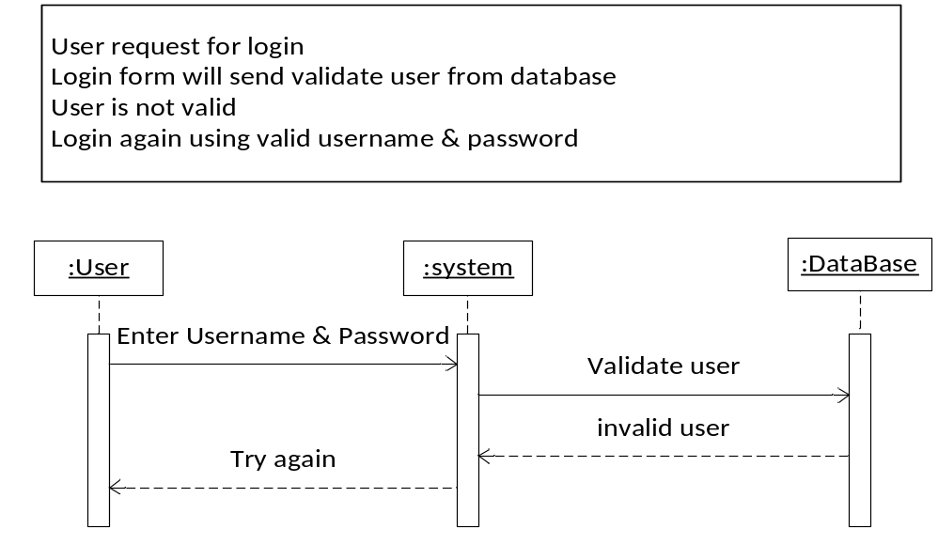 Fig 3.5: login exception Scenario & Sequence Diagram

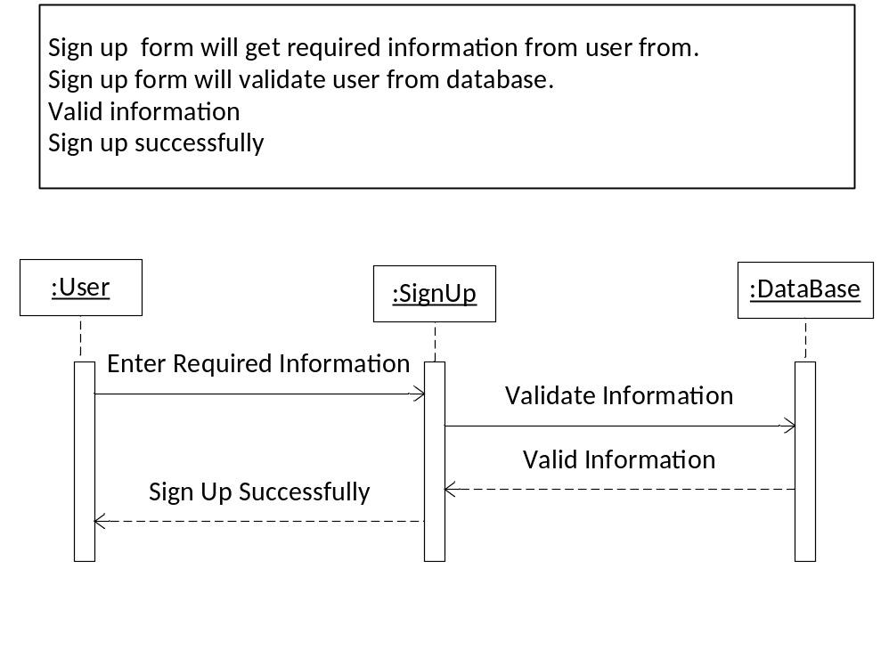 Fig 3.6: Sign Up Scenario & Sequence Diagram

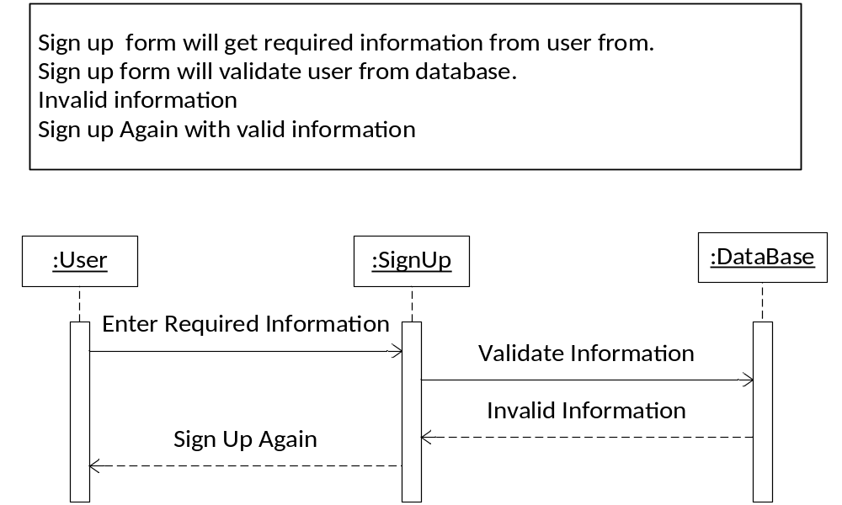
Fig 3.7: Sign up exception Scenario & Sequence

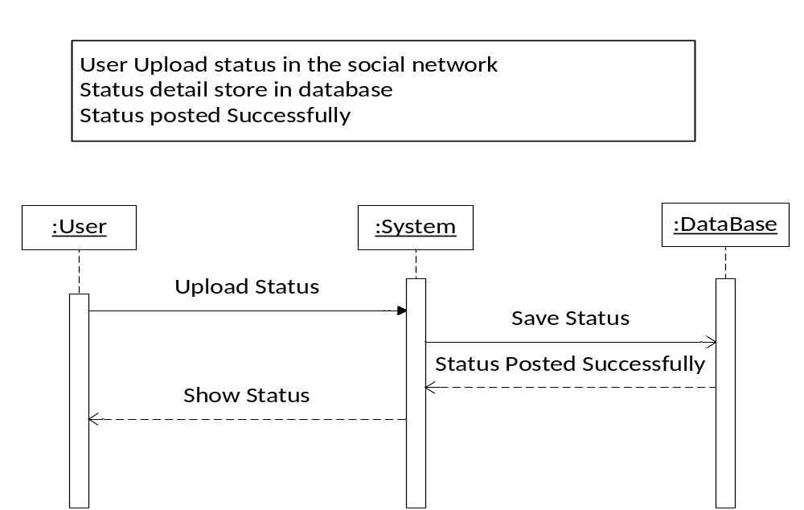
Fig 3.8: Status Upload Scenario & Sequence Diagram
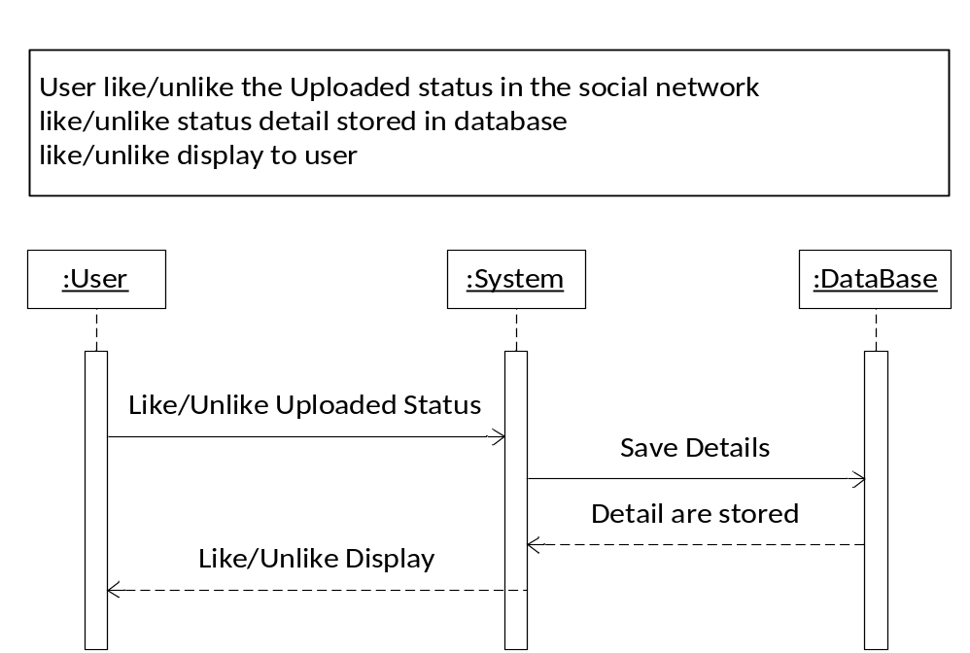
Fig 3.9: like/unlike Scenario & Sequence Diagram

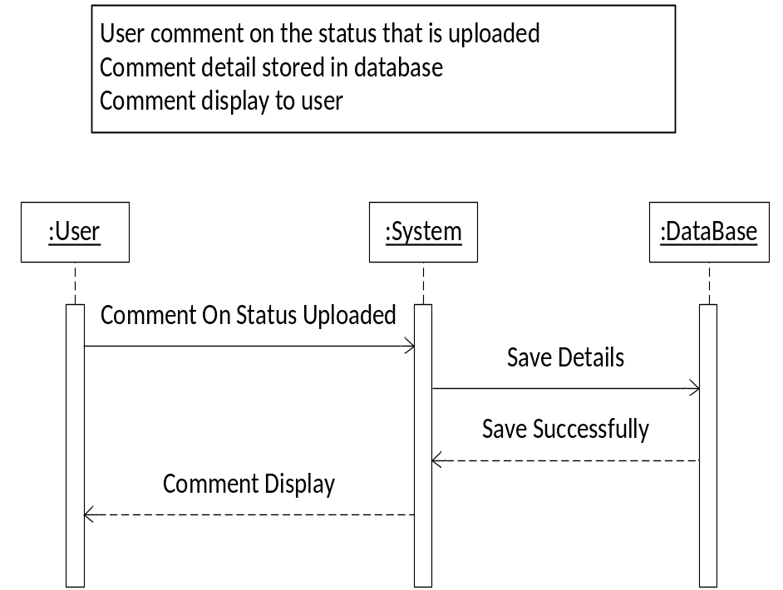
Fig 3.10: Comment on status Scenario & Sequence Diagram

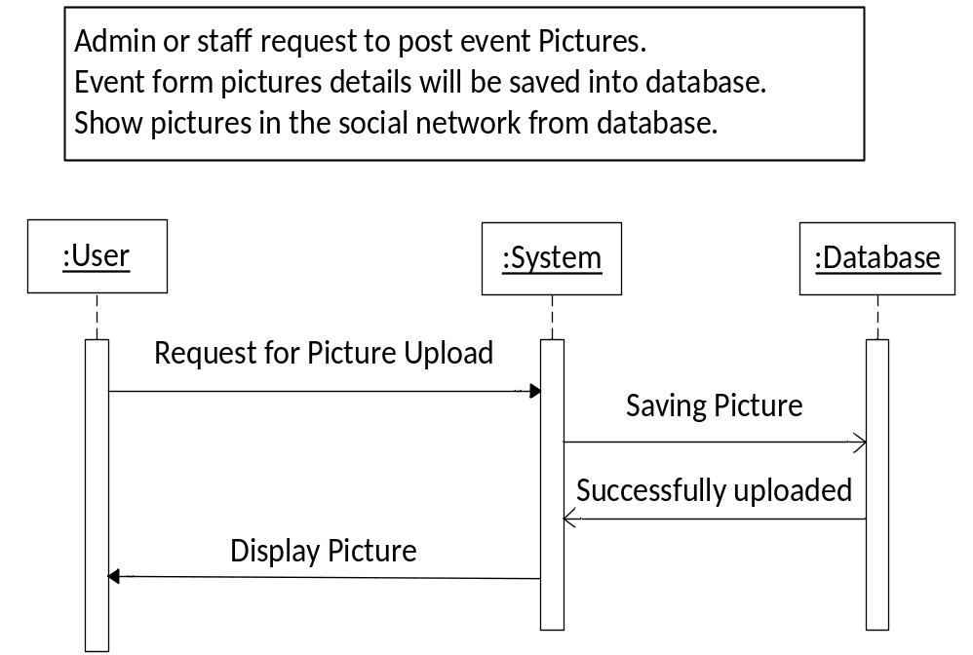 Fig 3.11: Event Gallery Scenario & Sequence Diagram

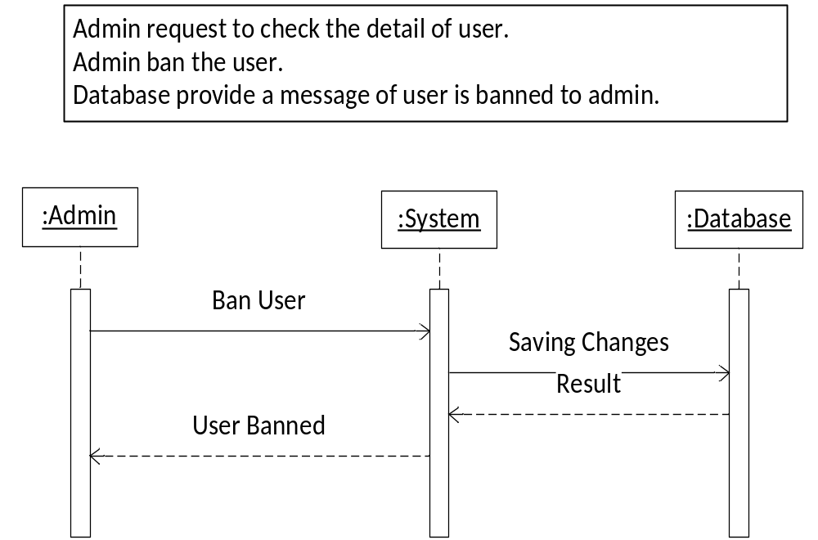Fig 3.12: BAN Scenario & Sequence Diagram

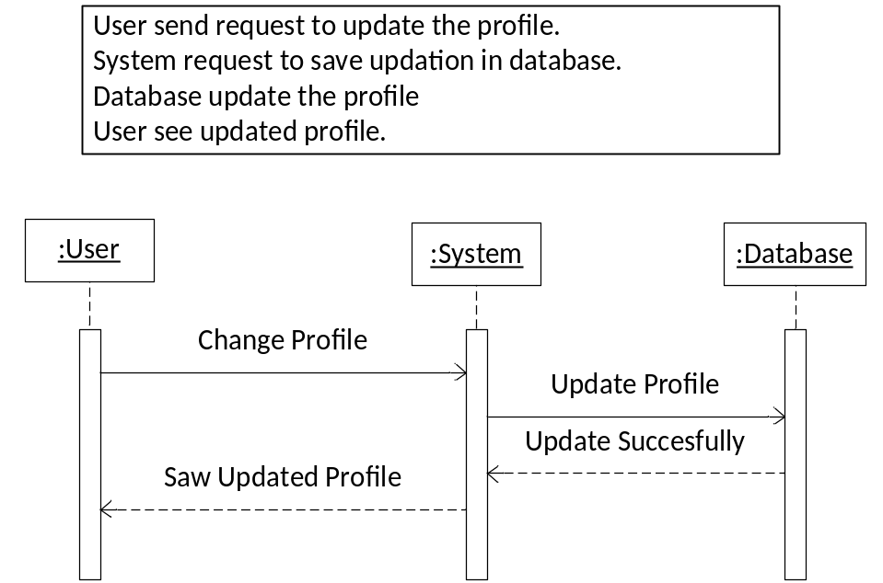

Fig 3.13: Profile Update Scenario & Sequence Diagram

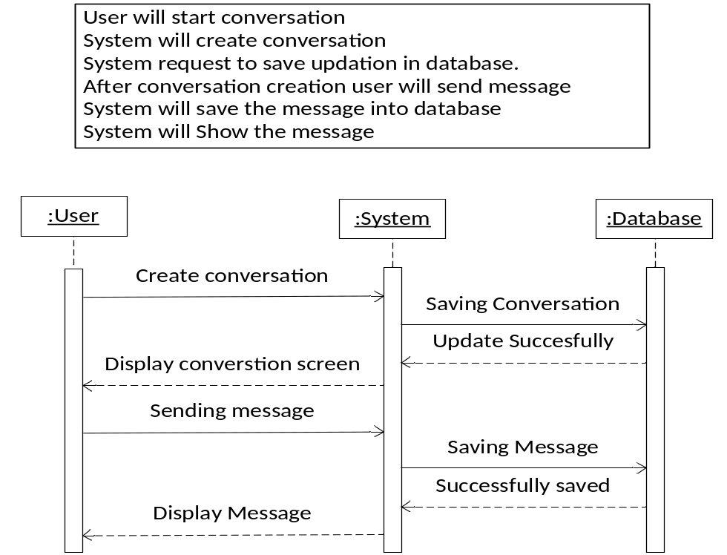
Fig 3.14: Chat Scenario & Sequence Diagram

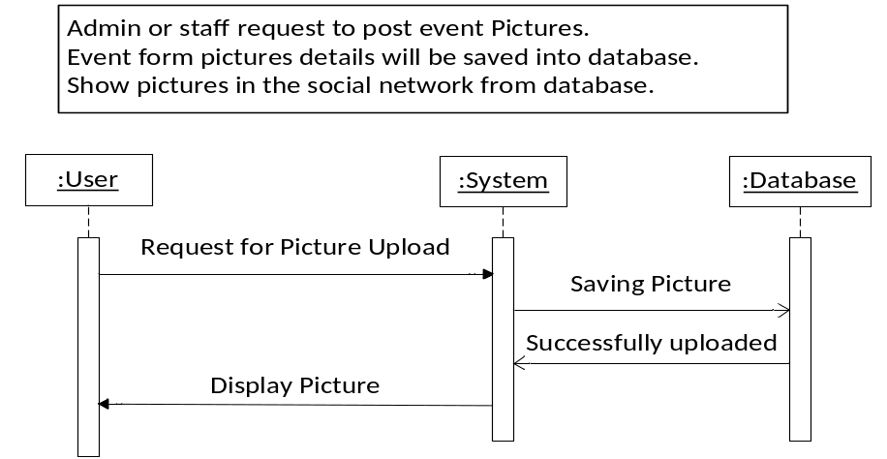

Fig 3.15: Picture Upload Scenario & Sequence Diagram

3.12 Activity Diagram
Activity diagrams represent workflows in an graphical way.

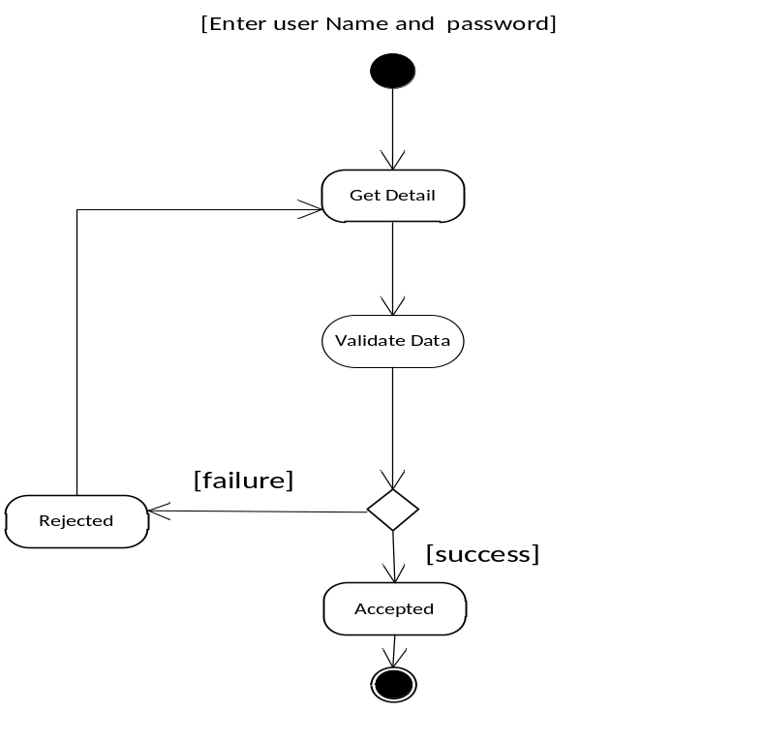
Fig 3.16: Activity Diagram for Login

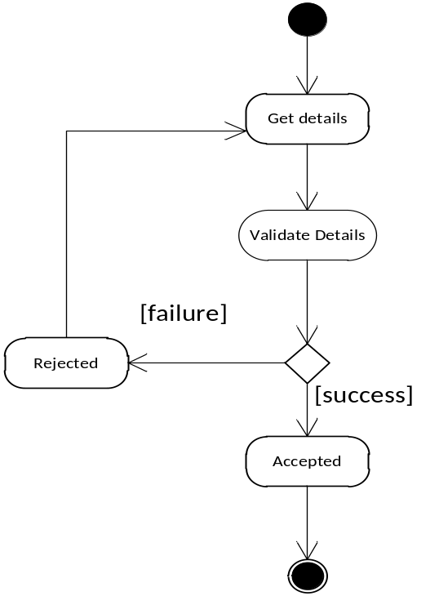

Fig 3.17: Activity Diagram for Member Registration

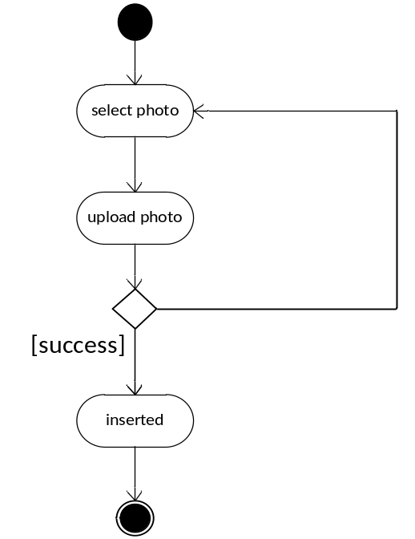
Fig 3.18: Activity Diagram for Upload Profile Picture
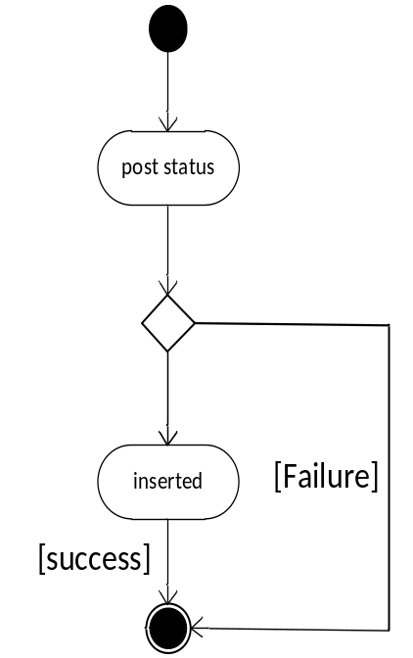
Fig 3.19: Activity Diagram for Status Post

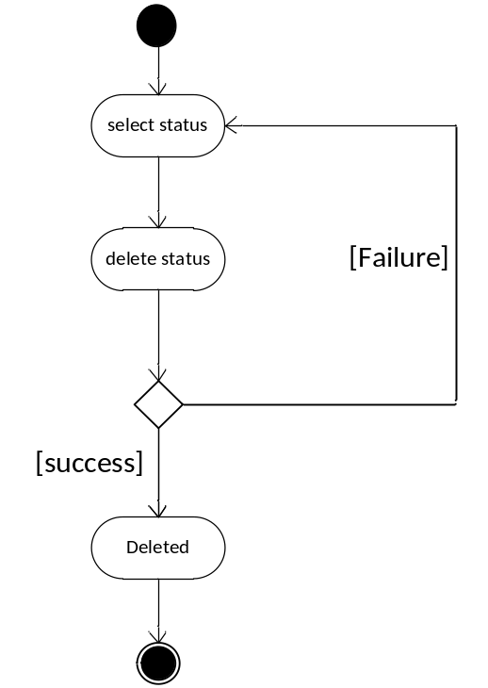
Fig 3.20: Activity Diagram for delete status

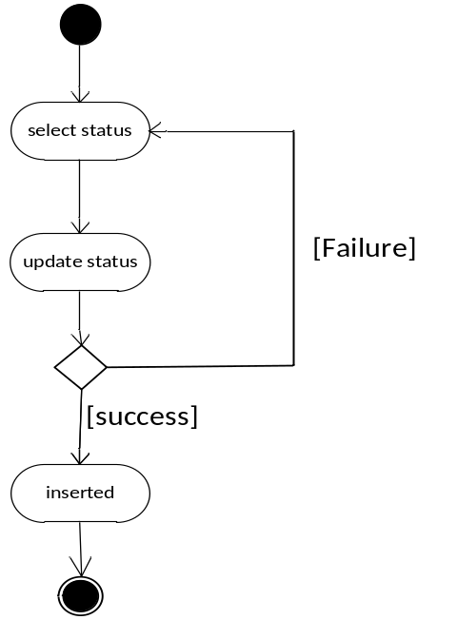

Fig 3.21: Activity Diagram for Status update

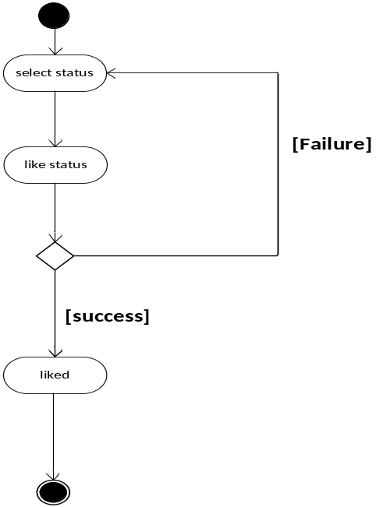
Fig 3.22: Activity Diagram for like status

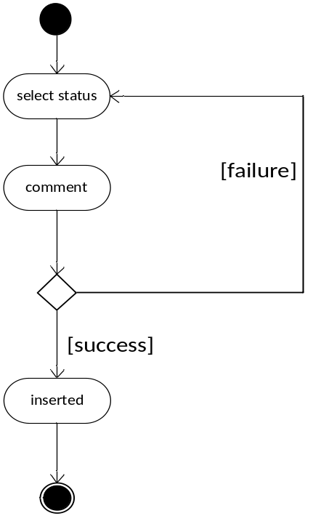

Fig 3.23: Activity Diagram for Comment Status

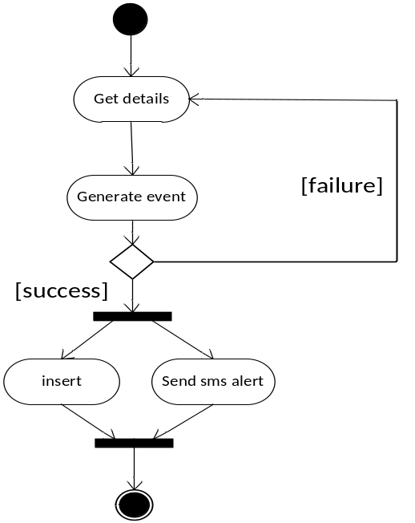
Fig 3.24: Activity Diagram for Event Alert

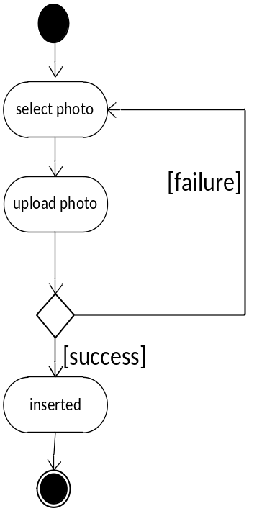

Fig 3.25: Activity Diagram for Event Gallery Photo upload

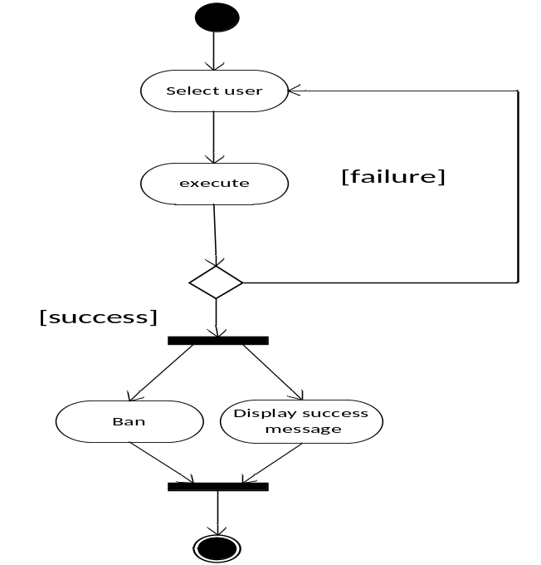 Fig 3.26: Activity Diagram for User Ban

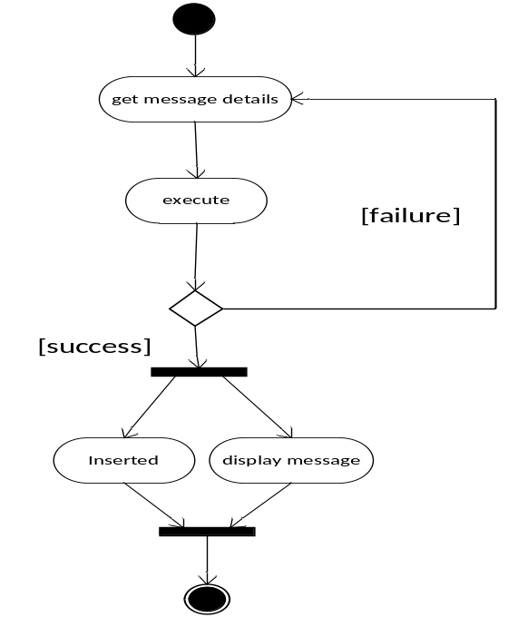

Fig 3.27: Activity Diagram for Message

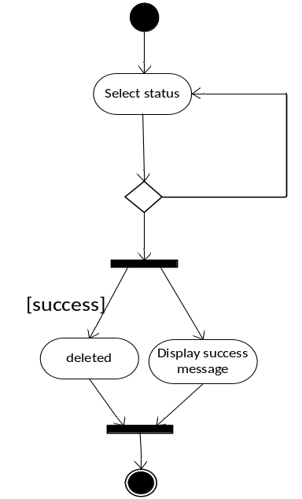
Fig 3.28: Activity Diagram for delete Status

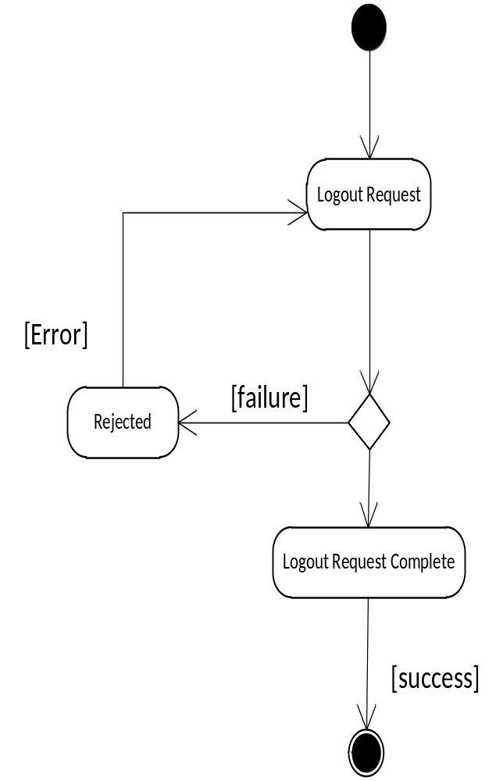

Fig 3.29: Activity Diagram for logout

Implementation:

In This section we have included the snapshots of what we have designed and developed.

4.1:Login Panel :
It is login panel of our system through which registered members can get access to our system

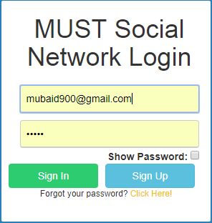

Fig 4.1 : login panel

4.2: Register User
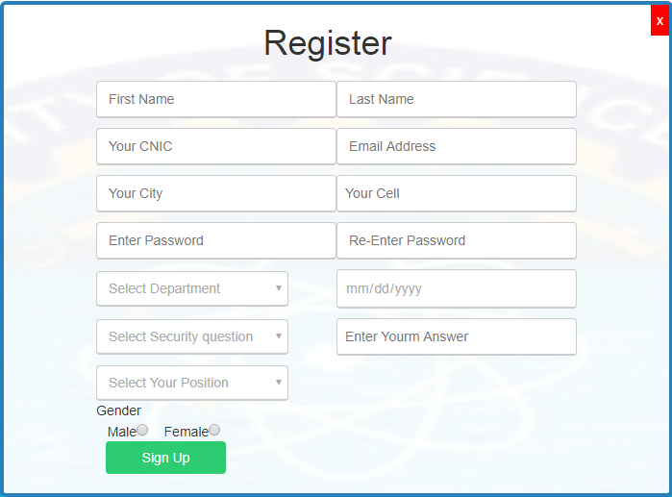

Fig 4.2: Register User

4.3 Add User

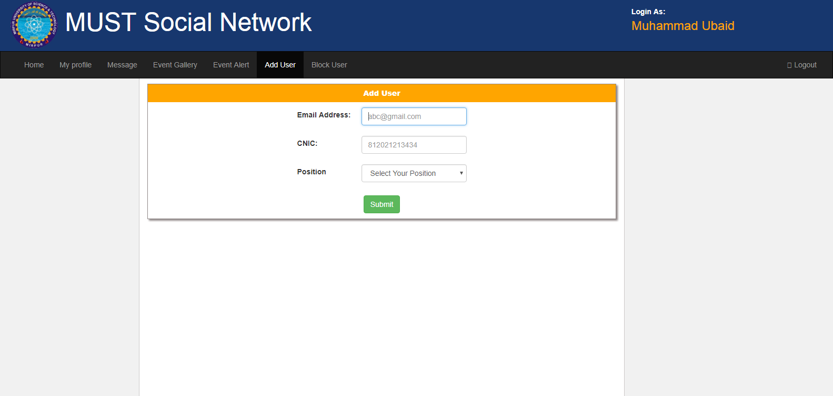

Fig 4.3: Add User

4.4 Block/Unblock User

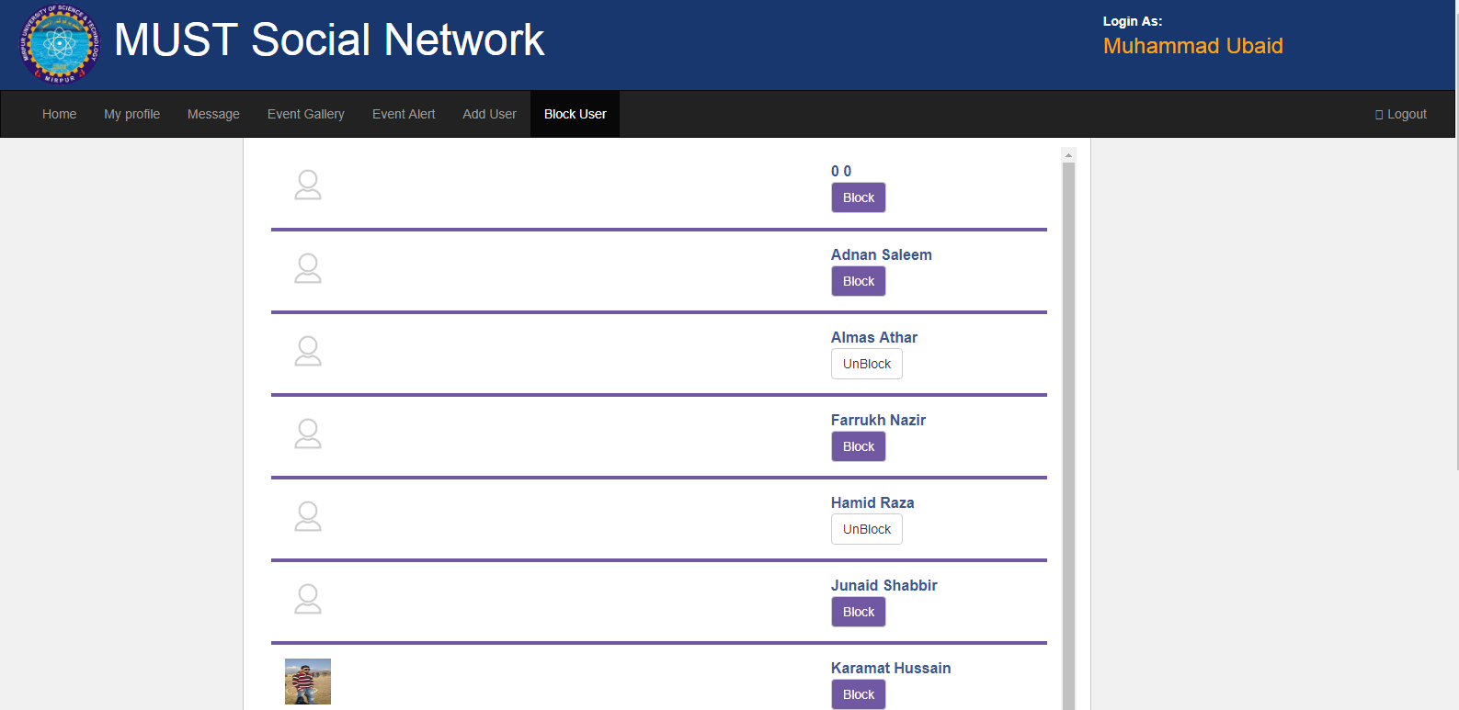

Fig 4.4: Block/Unblock User

4.5 Event Alert

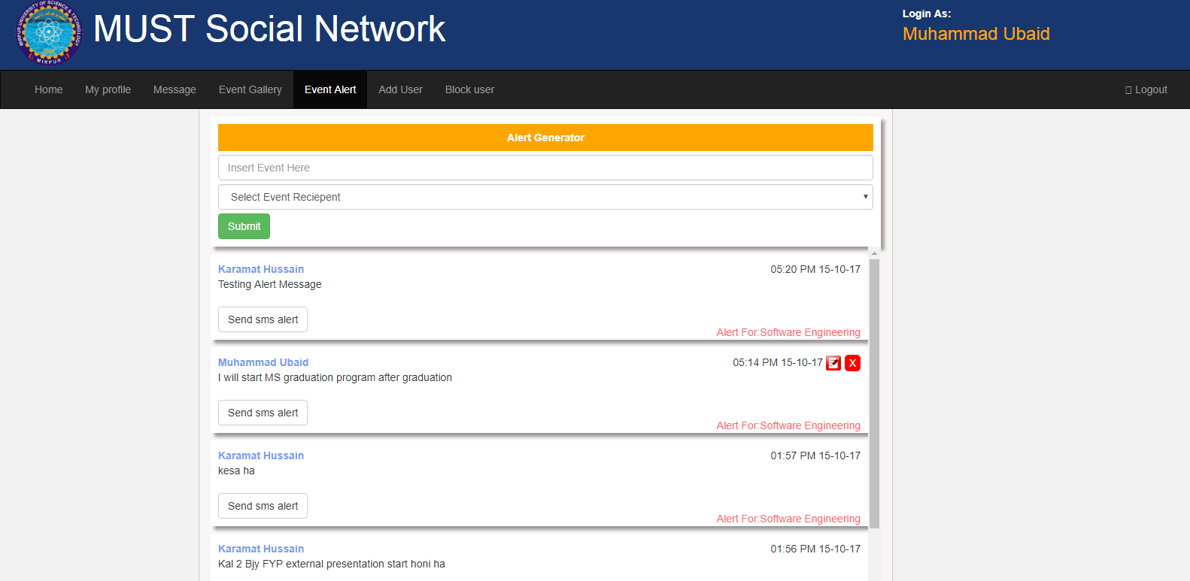

Fig 4.5: Event Alert

4.6 Event Gallery

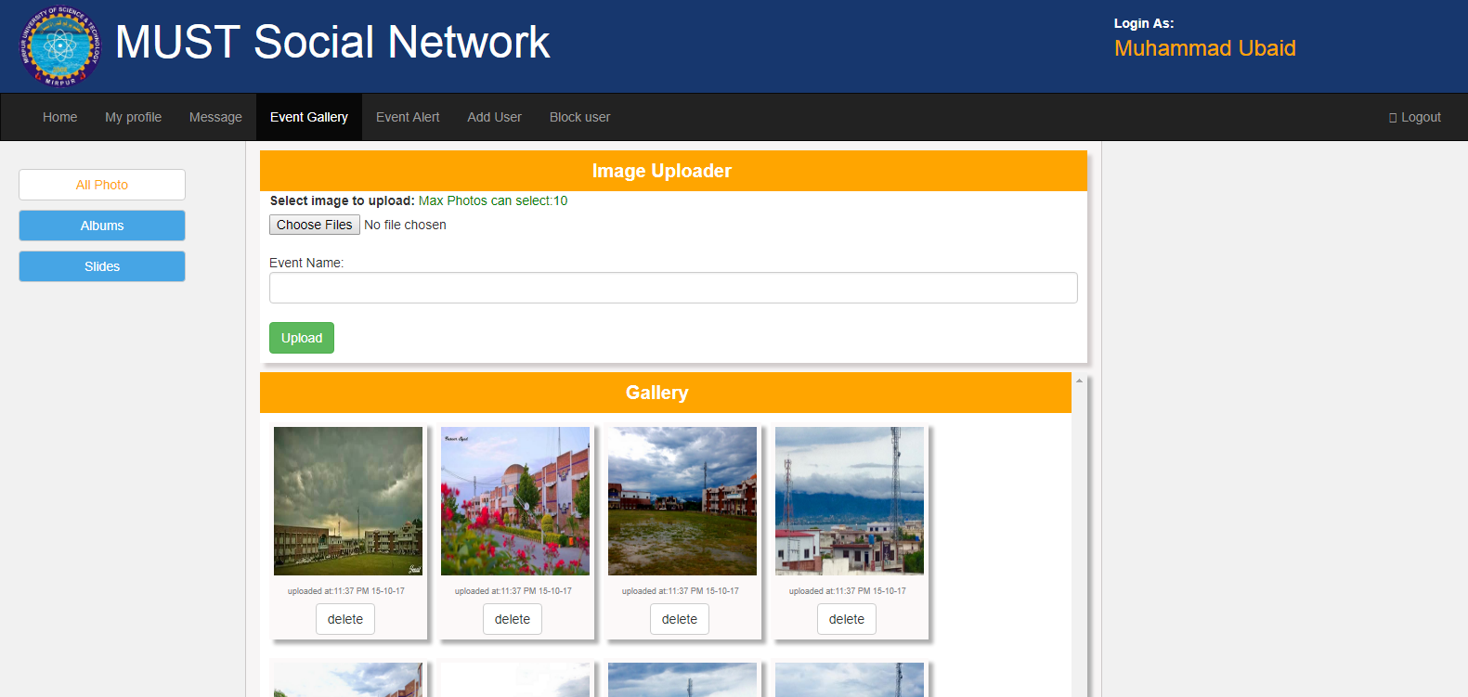

Fig 4.6: Event Gallery

4.7 : Messaging

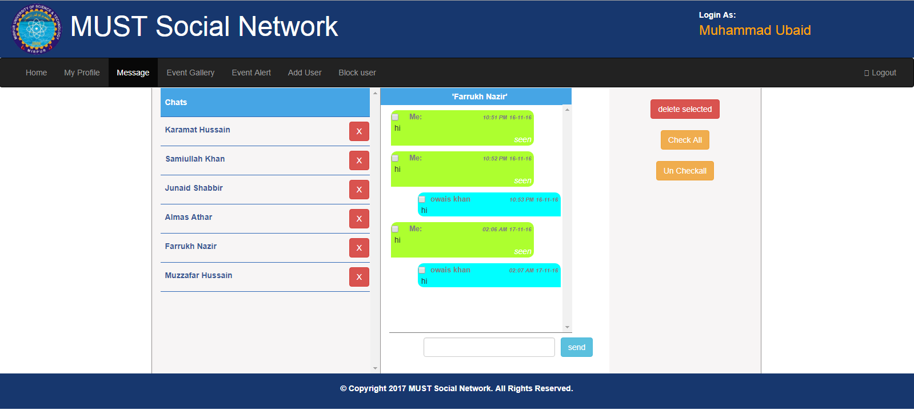

Fig 4.7: Messaging

4.8 : User Profile

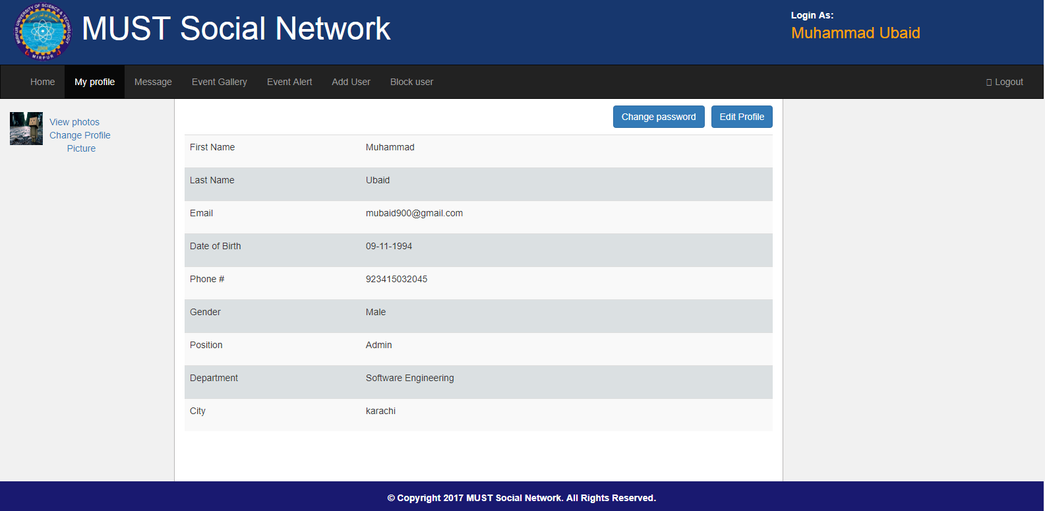

Fig 4.8 : User Profile

4.9 : Home Page
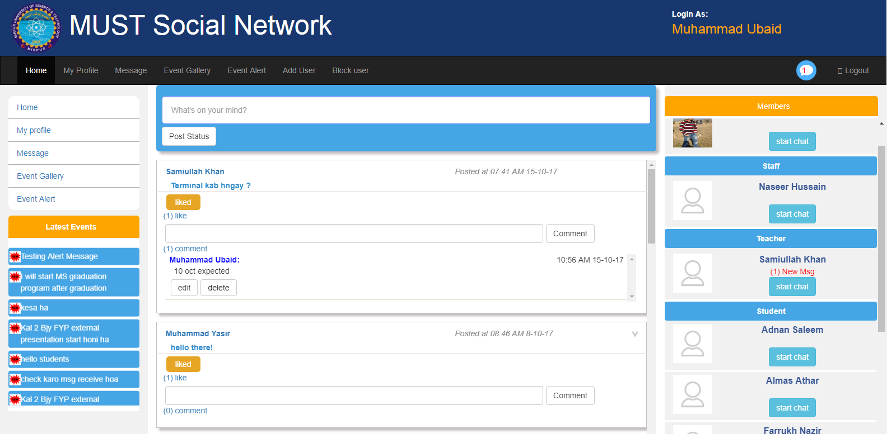
fig 4.9 : Home Page

Testing:

Software testing is a critical element of software quality assurance and represents the ultimate review of specification, design and coding. In fact, testing is the one step in the software engineering process that could be viewed as destructive rather than constructive. As a secondary benefit, testing demonstrates that software functions appear to be working according to the specification. Testing provides a good indication of software reliability and some indication of software quality as a whole. Testing cannot show the absence of defects, it can only show that software defects are present. Finally we arrive at system testing and we tried our best to test each individual module and also as an integrated modules (as a whole) with sufficient data that may an organization have, Fulfilling the objective of our “MUST social network”.

5.1 Psychology of Testing
The aim of testing is often to demonstrate that a program works by showing that it has no errors. The basic purpose of testing phase is to detect the errors that may be present in the program. Hence one should not start testing with the intent of showing that a program works, but the intent should be to show that a program doesn’t work with the intent of finding errors

5.2 Testing Objective
Objective of testing is to find maximum errors in the software. So, a good testing strategy is the one with high potential of finding errors and bugs.

- Testing is a process of executing a program with the intent of finding an error.
- A successful test is one that uncovers an as yet undiscovered error.
- A good test case is one that has a high probability of finding error, if it exists.
- The tests are inadequate to detect possibly present errors.
- The software more or less confirms to the quality and reliable standards.

5.3 The Box Approach

Traditionally software testing methods are divided into white- and black-box testing. These two approaches describe the point of view of test designer.

5.3.1 White Box testing

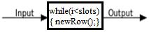

White-box testing, also known as clear box testing, glass box testing which tests internal workings of a program, instead of the functionality. In white-box testing detailed internal perspective of the system, as well as programming skills, are used to design test cases. . I tested step wise every piece of code, taking care that every statement in the code is executed at least once.

5.3.2 Black Box testing

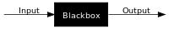

Black-box testing treats the software as a "black box", examining functionality without any knowledge of internal software workings. The tester is only aware of what the software is supposed to do, not how it does it, like the figure depicts, tester only knows the input and output and nothing more.

5.4 Levels of Testing

In order to uncover the errors present in different phases we have the concept of levels of testing. The basic levels of testing are as shown below

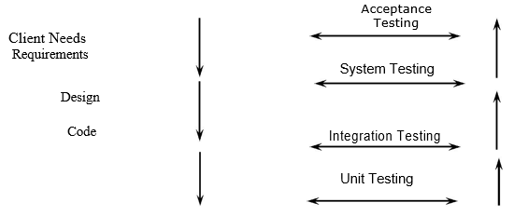
Fig 5.1: Level of Testing

5.5 Unit Testing
Unit testing focuses verification effort on the smallest unit of software i.e. the module. Using the detailed design and the process specifications testing is done to uncover errors within the boundary of the module. All modules must be successful in the unit test before the start of the integration testing begins.
In this application we tests the programs up as system. Unit testing is first done on modules, independent of one another to locate errors. This enables to detect errors. All components of our project were tested with driven programs. Even each function was tested individually using the test cases which are described at the end of chapter.

5.6 Integration Testing
After the unit testing we have to perform integration testing. The goal here is to see if modules can be integrated properly, the emphasis being on testing interfaces between modules. This testing activity can be considered as testing the design and hence the emphasis on testing module interactions. In this project integrating all the modules forms the main system. When integrating all the modules we have checked whether the integration effects working of any of the services by giving different combinations of inputs. All modules were collected and integrated to each other and results of each test were up to the mark.

5.7 System Testing
After testing each module and getting the expected results, here the modules are integrated to make sure that the application is well supporting its features. As a standalone application, its results are according to requirements, as expected. The application runs smoothly when executed.

- Application is reliable and less prone to crash.
- Application is capable enough to meet all the requirements of users.
- The application is easy to maintain.
- Application is easy to access when needed by user.

5.8 Alpha Testing
Alpha testing is specially used by product development organizations. Developers observe the users and note problems. Alpha testing is testing of an application when development is about to complete. Minor design changes can still be made as a result of alpha testing.

During alpha testing of our project we find following minor errors and solve them such as

  - Broken links
  - Spelling mistakes

5.9 Beta Testing
Beta Testing is conducted at the client’s place i.e. developer is not present while testing as it errors and other issues encountered during this testing and reports to the developer.

5.10 Acceptance Testing
Acceptance Test is performed with realistic data of the client to demonstrate that the software is working satisfactorily. Testing here is focused on external behavior of the system, the internal logic of program is not emphasized. In this project ‘MUST social network’ we tested whether project is working correctly or not.

5.11 Interface Testing
The system has been tested at interface level. The interface is tested to make sure that the form, menus, text boxes and buttons are operational and everything is displayed according to the requirement. For example menu strip of the Student Panel is tested.

5.12 MUST Social Network Testing
We tried our best to test each individual module and also integrated modules (as a whole) with sufficient data that the targeted organization may have, and debugged the software to an appreciable extent and we got success in this.

5.13 Test Cases
- Test cases are built around specifications and requirements, i.e., what the application is
Supposed to do,
Test cases are generally derived from external descriptions of the software, including
Specification, requirements and design parameters.
- The test designer determines input, output and possible flow of events without any knowledge of the software’s internal structure.

We built and run following test cases for black box testing.

5.13.1 Test Case 1: Sign-up

ID | 1
Name | Sign-up
Brief Description | Used to Sign-up
Expected Input | firstName, lastName, email, password, lastSeen. Cnic, city, dob,gender, position, ban, department
Expected flow of Events | Provide correct information and click on sign-up button
Alternate flow of Events | User Quits to sign-up form
Pre-Condition | New member must provide correct information
Post Condition | New Member is Added
Actor | Student, Teacher, Staff
Status | Pass

Table 5.13.1: Test Case Sign-up

5.13.2 Test Case 2: Login

ID | 2
Name | Login
Brief Description | Used to Login
Expected Input | email, password
Expected flow of Events | Provide correct information and click on Login button
Alternate flow of Events | User Quits to Login
Pre-Condition | User must provide correct information
Post Condition | User must Login
Actor | Admin, Student, Teacher, Staff
Status | Pass
Table 5.13.2: Test Case Login

5.13.3 Test Case 3: Create Conversation

ID | 3
Name | Create Conversation
Brief Description | Used to Create Conversation
Expected Input | firstPersonId, secondPersonId , del1, del2, date
Expected flow of Events | Conversation created
Alternate flow of Events | User Quits to create Conversation
Pre-Condition | User Exits
Post Condition | Conversation Created
Actor | Admin, Student, Teacher, Staff
Status | Pass
Table 5.13.3: Test Case View Conversation

5.13.4 Test Case 4: View Conversation

ID | 4
Name | Conversation
Brief Description | Used to Show Conversation
Expected Input
Expected flow of Events | Show Conversation if exits.
Alternate flow of Events | Nill
Pre-Condition | Exits Conversation
Post Condition | Conversation Shown
Actor | Admin, Student, Teacher, Staff
Status | Pass

Table 5.13.4: Test Case View Conversation

5.13.5 Test Case 5: Delete Conversation

ID | 5
Name | Delete Conversation
Brief Description | Used to Delete Conversation
Expected Input | Nil
Expected flow of Events | Click “Delete” button to delete Conversation
Alternate flow of Events | User Quits to delete Conversation
Pre-Condition | Conversation must exits
Post Condition | Conversation is deleted
Actor | Admin, Student, Teacher, Staff
Status | Pass

Table 5.13.5: Test Case Delete Conversation

5.13.6 Test Case 6: Check Conversation

ID | 6
Name | Check Conversation
Brief Description | Used to Check Conversation
Expected Input | firstPersonId, secondPersonId , date
Expected flow of Events | Previous Conversation check
Alternate flow of Events | User Quits to check Conversation
Pre-Condition | Conversation must exits
Post Condition | Conversation checked And show to user
Actor | Admin, Student, Teacher, Staff
Status | Pass

Table 5.13.6: Test Case Check Conversation

5.13.7 Test Case 7: Add Member

ID | 7
Name | Add Member
Brief Description | Used to Add Member
Expected Input | email, Cnic,
Expected flow of Events | New Member is Added in database by admin
Alternate flow of Events | User Quits to provide correct information
Pre-Condition | New member must provide correct information
Post Condition | User become able to join MUST network
Actor | Admin
Status | Pass

Table 5.13.7: Test Case Add Member

5.13.8 Test Case 8: Ban Member

ID | 8
Name | Ban Member
Brief Description | Used to Ban Member
Expected Input | firstName, lastName, email, password, lastSeen. Cnic, city, dob,gender, position, ban, department
Expected flow of Events | User may or may not ban
Alternate flow of Events | Admin Quits to Ban
Pre-Condition | User Exits
Post Condition | User Banned
Actor | Admin
Status | Pass

Table 5.13.8: Test Case Ban Member

5.13.9 Test Case 9: Show Member

ID | 9
Name | Show Member
Brief Description | Used to Show Member
Expected Input | firstName, lastName, email, password, lastSeen. Cnic, city, dob,gender, position, ban, department
Expected flow of Events | Members who are online are shown to other members
Alternate flow of Events | User Quits
Pre-Condition | Member Must Exits
Post Condition | Member shown
Actor | Admin, Student, Teacher, Staff
Status | Pass
Table 5.13.9: Test Case Show Member

5.13.10 Test Case 10: Status Check

ID | 10
Name | Status Check
Brief Description | Used to Status Check
Expected Input | Status, posterName, date
Expected flow of Events | Status is Checked to find where user become online or seen the status
Alternate flow of Events | Status not check if any error is occur
Pre-Condition | Status must exits
Post Condition | Status checked
Actor | Admin, Student, Teacher, Staff
Status | Pass

Table 5.13.10: Test Case Status Check

5.13.10 Test Case 10: Status Check

ID | 10
Name | Status Check
Brief Description | Used to Status Check
Expected Input | Status, posterName, date
Expected flow of Events | Status is Checked to find where user become online or seen the status
Alternate flow of Events | Status not check if any error is occur
Pre-Condition | Status must exits
Post Condition | Status checked
Actor | Admin, Student, Teacher, Staff
Status | Pass

Table 5.13.10: Test Case Status Check

5.13.11 Test Case 11: view Profile

ID | 11
Name | View Profile
Brief Description | Used to View Profile
Expected Input | firstName, lastName, email, password, lastSeen. Cnic, city, dob,gender, position, ban, department
Expected flow of Events | User must views his own profile
Alternate flow of Events | User Quits to View profile
Pre-Condition | Profile must exits
Post Condition | Profile viewed by user
Actor | Admin, Student, Teacher, Staff
Status | Pass

Table 5.13.11: Test Case View Profile

5.13.12 Test Case 12: Update Profile

ID | 12
Name | Update Profile
Brief Description | Used to Update profile
Expected Input | firstName, lastName, email, password, lastSeen. Cnic, city, dob,gender, position, ban, department
Expected flow of Events | User should update his own profile
Alternate flow of Events | User Quits to update his profile
Pre-Condition | Profile must exits
Post Condition | Profile updated
Actor | Admin, Student, Teacher, Staff
Status | Pass

Table 5.13.12: Test Case Update Profile

5.13.13 Test Case 13: Delete Member

ID | 13
Name | Delete Member
Brief Description | Used to delete Member
Expected Input | Member Id
Expected flow of Events | Member deleted
Alternate flow of Events | User Quits to sign-up form
Pre-Condition | Member must exist
Post Condition | New Member is Added
Actor | Admin, Student, Teacher, Staff
Status | Pass

Table 5.13.13: Test Case Delete Member

5.13.14 Test Case 14: View Status

ID | 14
Name | View Status
Brief Description | Used to view Status.
Expected Input | Nill
Expected flow of Events | Status viewed by users that are available
Alternate flow of Events | Status not viewed by user
Pre-Condition | Status exists
Post Condition | Status Viewed
Actor | Administrator, Teacher, Staff, Student
Status | Pass
Table 5.13.14: Test Case View Status

5.13.15 Test Case 15: Delete Status

ID | 15
Name | Delete Status
Brief Description | Used to delete Status
Expected Input | Status, posterName, date
Expected flow of Events | Select Status And Delete the Status
Alternate flow of Events | User Quits
Pre-Condition | Status exist
Post Condition | Status deleted
Actor | Administrator, Teacher, Staff, Student
Status | Pass

Table 5.13.15: Test Case Delete Status

5.13.16 Test Case 16: Update Status

ID | 16
Name | Update Status
Brief Description | Used to Update Status
Expected Input | Satus, posterName, date
Expected flow of Events | Select Status And Update the Status
Alternate flow of Events | User Quits
Pre-Condition | Status exist
Post Condition | Status Updated
Actor | Administrator, Teacher, Staff, Student
Status | Pass

Table 5.13.16: Test Case Update Status

5.13.17 Test Case 17: Insert Status

ID | 17
Name | Insert Status
Brief Description | Used to Insert Status
Expected Input | Status, posterName, date
Expected flow of Events | Select Status ID And insert the Status
Alternate flow of Events | User Quits
Pre-Condition | Status exist
Post Condition | Status Inserted
Actor | Administrator, Teacher, Staff, Student
Status | Pass

Table 5.13.17: Test Case Insert Status

5.13.18 Test Case 18: Insert Profile Picture

ID | 18
Name | Picture Insert
Brief Description | Used to Picture Insert
Expected Input | Name, picHolderid, picDate, currentStatus
Expected flow of Events | Profile Picture inserted
Alternate flow of Events | User Quits to insert profile picture
Pre-Condition | Profile exits
Post Condition | Profile Picture inserted
Actor | Admin, Student, Teacher, Staff
Status | Pass

Table 5.13.18: Test Case Insert Profile Picture

5.13.19 Test Case 19: Show Profile Picture

ID | 19
Name | Show Profile Picture
Brief Description | Used to Show Profile Picture
Expected Input | name, picHolderid, picDate, currentStatus
Expected flow of Events | Profile picture is shown to the users who are the part of this network.
Alternate flow of Events | Profile picture is not shown due to some error
Pre-Condition | Picture exits
Post Condition | Profile picture is shown successfully
Actor | Admin, Student, Teacher, Staff
Status | Pass

Table 5.13.19: Test Case Show Profile Picture

5.13.20 Test Case 20: Change Profile Picture

ID | 20
Name | Change Profile Picture
Brief Description | Used to Change Profile Picture
Expected Input | Name, picHolderid, picDate, currentStatus
Expected flow of Events | Every user change his own profile picture
Alternate flow of Events | User Quits to change picture
Pre-Condition | Profile exits in order to change profile picture
Post Condition | Profile picture changed
Actor | Admin, Student, Teacher, Staff
Status | Pass

Table 5.13.20: Test Case Change Profile Picture

5.13.21 Test Case 21: Delete Profile Picture
ID | 21
Name | Delete Profile Picture
Brief Description | Used to Delete Profile Picture
Expected Input | Name, picHolderid, picDate, currentStatus
Expected flow of Events | User delete his own profile picture
Alternate flow of Events | User Quits to delete picture
Pre-Condition | Profile picture exits
Post Condition | Profile picture deleted
Actor | Admin, Student, Teacher, Staff
Status | Pass

Table 5.13.21: Test Case Delete Profile Picture

5.13.22 Test Case 22: Insert Photo In Event Gallery
ID | 22
Name | Insert Photo In Gallery
Brief Description | Used to Insert Photo In Album
Expected Input | eventName, photoName, date
Expected flow of Events | Photo is inserted in album
Alternate flow of Events | User Quits
Pre-Condition | Photo album exits
Post Condition | News photos are inserted in album
Actor | Admin, Staff
Status | Pass

Table 5.13.22: Test Case Insert Photo In Album

5.13.23 Test Case 23: Delete Photo From Album
ID | 23
Name | Delete Photo From Album
Brief Description | Used to Delete Photo From Album
Expected Input | eventName, photoName, date
Expected flow of Events | Album photos deleted
Alternate flow of Events | User Quits
Pre-Condition | Photo album should exits
Post Condition | Photo album is deleted
Actor | Admin,Staff
Status | Pass

Table 5.13.23: Test Case Delete Photo From Album

5.13.24 Test Case 24: Show Album Photo
ID | 24
Name | Show Album Photo
Brief Description | Used to Show Album Photo
Expected Input | eventName, photoName, date
Expected flow of Events | Album photos are shown to everyone
Alternate flow of Events | Photos are not shown due to some fault
Pre-Condition | Photo Album must exits
Post Condition | Photos in album are shown
Actor | Admin, Student, Teacher, Staff
Status | Pass

Table 5.13.24: Test Case Show Album Photo

5.13.25 Test Case 25: Slider

ID | 25
Name | Slider
Brief Description | Used to Show Slider
Expected Input | eventName, photoName, date
Expected flow of Events | Pictures in slider are shown to everyone who join the network
Alternate flow of Events | Slider is not Shown to user
Pre-Condition | Pictures exits
Post Condition | Pictures are shown in slider
Actor | Admin, Student, Teacher, Staff
Status | Pass
Table 5.13.25: Test Case Slider

5.13.26 Test Case 26: Add Event

ID | 26
Name | Add Event
Brief Description | Used to Add Event
Expected Input | event, alertReciever, date
Expected flow of Events | Event is added by admin and send it to user mobile phone through text message
Alternate flow of Events | No event is added by admin
Pre-Condition | User must exits in order to send an event
Post Condition | Event is received by the user
Actor | Admin, Staff
Status | Pass

Table 5.13.26: Test Case Add Event

5.13.27 Test Case 27: Edit Event

ID | 27
Name | Edit Event
Brief Description | Used to Edit Event
Expected Input | eventName, photoName, date
Expected flow of Events | Admin change or update the event and then send to the user
Alternate flow of Events | Admin Quits to edit the event
Pre-Condition | Event exits in order to edit it
Post Condition | Changed or updated event is send to the user
Actor | Admin, Staff
Status | Pass

Table 5.13.27: Test Case Add Member

5.13.28 Test Case 28: Delete Event

ID | 28
Name | Delete Event
Brief Description | Used to Delete Event
Expected Input | eventName, photoName, date
Expected flow of Events | Admin delete the event after sending it to the user
Alternate flow of Events | Admin Quits to delete an event after sending it to the user
Pre-Condition | Event exits
Post Condition | Event deleted
Actor | Admin, Staff
Status | Pass

Table 5.13.28: Test Case Delete Event

5.13.29 Test Case 29: Show Event
ID | 29
Name | Show Event
Brief Description | Used to Show Event
Expected Input | Admin change or update the event and then send to the user
Expected flow of Events | Event successfully shown to the user after sending from the admin
Alternate flow of Events | Events are not shown to user due to some fault
Pre-Condition | Event must exits
Post Condition | Event shown
Actor | Admin, Student, Teacher, Staff
Status | Pass

Table 5.13.29: Test Case Show Event

5.13.30 Test Case 30: Like

ID | 30
Name | Like
Brief Description | Used to Like the status.
Expected Input | likerId likerName, likes
Expected flow of Events | like status
Alternate flow of Events | Leave the status button without liking
Pre-Condition | Status Exits
Post Condition | Status liked
Actor | Admin, Student, Teacher, Staff
Status | Pass
Table 5.13.30: Test Case Like

ID | 31
Name | Unlike
Brief Description | Used to unlike the Status.
Expected Input | likerId likerName, likes
Expected flow of Events | Unlike the Status
Alternate flow of Events | Leave the status button without unliking
Pre-Condition | Status Exists
Post Condition | Status Unlike
Actor | Admin, Student, Teacher, Staff
Status | Pass

5.13.31 Test Case 31: Unlike

Table 5.13.31: Test Case Unlike

5.13.32 Test Case 32: Like Show

ID | 32
Name | Like show
Brief Description | Used to Like show
Expected Input | likerId likerName, likes
Expected flow of Events | The like that is done by the user is shown
Alternate flow of Events | Like is not shown to user
Pre-Condition | Status Exists
Post Condition | Like is shown to the user
Actor | Admin, Student, Teacher, Staff
Status | Pass

Table 5.13.32: Test Case: Like Show

5.13.33 Test Case 33: Like Count

ID | 33
Name | Like Count
Brief Description | Used to Like Count
Expected Input | likerId likerName, likes
Expected flow of Events | The likes that are done by the user are counted
Alternate flow of Events | Likes are not counted
Pre-Condition | Status Exists
Post Condition | Likes are counted successfully are shown to the user
Actor | Admin, Student, Teacher, Staff
Status | Pass

Table 5.13.33: Test Case Like Count

5.13.34 Test Case 34: Insert Message

ID | 34
Name | Insert Message
Brief Description | Used to Insert Message
Expected Input | Message, senderId, senderName, recieverId, status, date
Expected flow of Events | The message is inserted by the user in order to send it to other user weather they are online or offine
Alternate flow of Events | Message is not inserted by the user
Pre-Condition | User Exists in order to insert message
Post Condition | Message inserted
Actor | Admin, Student, Teacher, Staff
Status | Pass

Table 5.13.34: Test Case Insert Message

5.13.35 Test Case 35: Delete Message

ID | 35
Name | Delete Message
Brief Description | Used to Delete the message
Expected Input | Message, senderId, senderName, recieverId, status, date
Expected flow of Events | Message is deleted by the user which is send to the other user. The message is deleted from the side of the user who delete it not delete from both sides.
Alternate flow of Events | Message delete
Pre-Condition | messageExists
Post Condition | Deleted Message is not shown to the user who delete it
Actor | Admin, Student, Teacher, Staff
Status | Pass

Table 5.13.35: Test Case Delete Message

5.13.36 Test Case 36: Show Message

ID | 36
Name | Show Message
Brief Description | Used to Show the Message
Expected Input | Message, senderId, senderName, recieverId, status, date
Expected flow of Events | The message is show to the user that is send by the other user.
Alternate flow of Events | Message is not show to the user
Pre-Condition | Message Exists
Post Condition | Message is shown to the user
Actor | Admin, Student, Teacher, Staff
Status | Pass

Table 5.13.36: Test Case Show Message

5.13.37 Test Case 37: Check Message Status

ID | 37
Name | Check Message status
Brief Description | Used to Check Message status
Expected Input | Message, senderId, senderName, recieverId, status, date
Expected flow of Events | Check the status of the message whether the message is seen by the user or not
Alternate flow of Events | Message status is not checked
Pre-Condition | message Exists
Post Condition | Message of the status is checked
Actor | Admin, Student, Teacher, Staff
Status | Pass

Table 5.13.37: Test Case Check Message Status

5.13.38 Test Case 38: Add Comment

ID | 38
Name | Add Comment
Brief Description | Used to Add Comment
Expected Input | comment, commenterId, commenterName, date
Expected flow of Events | Comment on Status
Alternate flow of Events | Not Comment on Status
Pre-Condition | Status exists
Post Condition | Comment On Status
Actor | Admin, Student, Teacher, Staff
Status | Pass

Table 5.13.38: Test Case Add Comment

5.13.39 Test Case 39: Edit Comment

ID | 39
Name | Edit Comment
Brief Description | Used to Edit the Comment
Expected Input | comment, commenterId, commenterName, date
Expected flow of Events | 1.Edit the Comment | 2. Add new comment.
Alternate flow of Events | User Quits
Pre-Condition | Status Exits
Post Condition | Update comment
Actor | Admin, Student, Teacher, Staff
Status | Pass

Table 5.13.39: Test Case Edit Comment

5.13.40 Test Case 40: Delete Comment

ID | 40
Name | Delete Comment
Brief Description | Used to Delete the comment.
Expected Input | comment, commenterId, commenterName, date
Expected flow of Events | Delete comment
Alternate flow of Events | User Quits/Don’t delete the comment
Pre-Condition | Status Exits
Post Condition | Comment is Deleted
Actor | Admin, Student, Teacher, Staff
Status | Pass

Table 5.13.40: Test Case Delete Comment

5.13.41 Test Case 41: Show Comment

ID | 41
Name | Show Comment
Brief Description | Used to Show Comment
Expected Input | comment, commenterId, commenterName, date
Expected flow of Events | Comment show to the user and other users who join the network
Alternate flow of Events | Comment is not shown
Pre-Condition | Comment must exits
Post Condition | The comment on status is shown to the user
Actor | Admin, Student, Teacher, Staff
Status | Pass

Table 5.31.41 Test Case Show Comment

Conclusion And Future Work:

6.1 Conclusion

It has been a great pleasure for us to work on this exciting and challenging project. During our four years of university life in MUST we feel that there is lack of communication among teachers and students. There is no effective alert service which alert all the student and other members of university in time. Using this departments of MUST can alert their students about exams.

This project proved good for us as it provided practical knowledge in PHP, AJAX, JQUERY, and JAVASRIPT. We learn how to use PHP and Ajax together to provide an environment like online chat where window load data without getting refresh. JQuery provide us different effects like slide down, slide up, hide and show a window. Also about all handling procedure related with “MUST social network’.

Development of this software also provides knowledge about the latest technology used in developing web enabled application and client server technology that will be great demand in future. This will provide better opportunities and guidance in future in developing projects independently. We also came to know that how some websites uses different languages to facilitate their target audience.

Social Networking website is a revolutionary idea with a very bright future with further scope for advancements. The opportunities provided from this medium are immense and many organizations are making use of this medium to better their practices. Online communities and Blogs are becoming very popular and moreover since the advancement of embedded systems people can use them “on the go” with the help of handheld devices like cell phones or palmtops. The world is getting closer every day and everyone wants to be connected. Static blogs and websites are losing popularity. World is moving more towards "information streams". The information comes to users rather than users have to make effort to get the information.

The proposed system is built successfully and it performs according to the requirements specified in the requirements specification document. System is satisfactorily tested with example data, it provides intended results. It is found to be bug free as per the testing standards that are implemented. We hope that it will be helpful for MUST in future. University has not a platform where student can discuss their problems. The alert system will be very useful in alerting students about different events.

6.2 Future Improvements
Enhancement and changes can be made to the software, files or procedures to meet the emerging requirements. Since organization systems and the business environment undergo continual changes, the information system should keep place.

As the system has a database so in future, it can easily be extended to include a management system that may contain all records. This extension will help the administration to let go the paper work and do their work with simple clicks.

Photo upload in status can be added in future according to requirements of audience. Friend Tag future can be also added. One friend can tag other friend can tag other friends in his post or in a photo

In chat typing feature can also be added by using this feature user can know that the other user is typing something or not.

In event gallery modifications can also be made. Slide effects can be added. User can view photo using different effects.

6.3 Limitations

- The size of the database increases day-by-day, increasing the load on the database back up and data maintenance activity.

- We are not professional software engineers and developers. So there may be some minor mistakes.

- There may be flexibility needed in some cases.

- Only MUST staff, teachers & students can join this network

Conclusion
_________________________________________________________________

It has been a great pleasure for us to work on this exciting and challenging project. During our four years of university life in MUST we feel that there is lack of communication among teachers and students. There is no effective alert service which alert all the student and other members of university in time. Using this departments of MUST can alert their students about exams.

This project proved good for us as it provided practical knowledge in PHP, AJAX, JQUERY, and JAVASRIPT. We learn how to use PHP and Ajax together to provide an environment like online chat where window load data without getting refresh. JQuery provide us different effects like slide down, slide up, hide and show a window. Also about all handling procedure related with “MUST social network’.

Development of this software also provides knowledge about the latest technology used in developing web enabled application and client server technology that will be great demand in future. This will provide better opportunities and guidance in future in developing projects independently. We also came to know that how some websites uses different languages to facilitate their target audience.

Referencing
_________________________________________________________________

We take help from the following books and web Sites for the software engineering and development of this project.

[i] Michal Bah .Object Oriented Modeling with UML 2.0 . Publisher: PEARSON EDUCATION, 2007

[ii] Summerville, Ian (2011). Software engineering. Boston: Pearson. ISBN 0-13-705346-0

FOR DEPLOYMENT [Access Date: Sep-2017 ]

https://www.youtube.com/watch?v=Nm5n9MMVOuI

http://www.w3schools.com/bootstrap/bootstrap_buttons.asp

http://www.w3schools.com/bootstrap/bootstrap_forms.asp

http://stackoverflow.com/questions/33197179/ajax-delete-multiple-records-with-checkboxes
http://api.jquery.com/slidetoggle/
http://asethome.org/soft/soft_Process2.html

